**WEEK-22 EXERCISE ( ANSWER KEY )**

**I/**

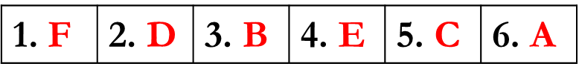**II/**

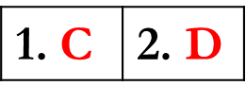**III/**

|  |  |  |  |  |
| --- | --- | --- | --- | --- |
| **1. any** | **2. an / a** | **3. am / some** | **4. some** | **5. is / any** |
| **6. any** | **7. Is / some** | **8. an** | **9. a / some** | **10. is / any** |
| **11. are / any** | **12. some** | **13. some / a** | **14. some / some** | **15. any** |

**IV/**

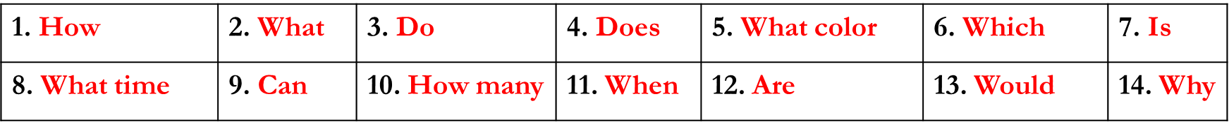**V/**

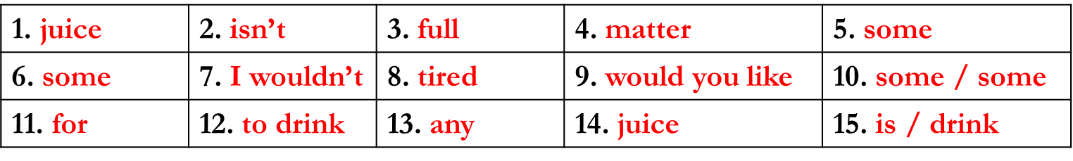**VI/**

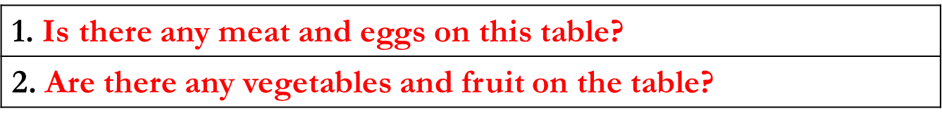

**VII/**

|  |  |  |  |
| --- | --- | --- | --- |
| **27. False** | **28. True** | **29. True** | **30. False** |

**VIII/**



1. **Multiple choice:**

**UNIT 10 – C & UNIT 11 – A1,2**

1. Lemonade is my favorite_________.

A. food B. drink C. fruit D. vegetables

1. How much is____________pens?

A. a dozen of B. two dozens C. a dozen D. two dozens of

1. How__________ do you need? – Half a kilo, please.

A. many B. much C. many beef D. much beef

1. His favorite fruit is __________

A. fish B. cream C. banana D. milk

1. Is a ____________ of chocolate 30,000 VND?

A. bottle B. box C. dozen D. bar

1. ______ grams of meat do you want? – Half a kilo, please.

A. How many B. How much C. What D. How

1. Your hamburger is here. Do you want________________?

A. else B. else anything C. anything else D. anything

1. What’s her_________ fruit? – Bananas.

A. favorite B. routine C. vegetable D. healthy

1. I’d like a___________ of toothpaste and a__________ of soap.

A. tube / bar B. bar / tube C. bottle / can D. can / box

1. I’d like a can of peas, please. – ______________.

A. No, thanks so much. C. Your cans of pea here.

B. You’re welcome. D. Sure, here you are.

1. **Read the passage, then write True or False:**

Today is Sunday. Lan and her mother go to the store. They want to buy some rice, beef, and pork for dinner. They need a bottle of cooking oil. Lan wants some oranges and chocolate. They want five oranges and two boxes of chocolates. They also want some bananas and apples. They want two kilos of bananas and six apples.

* + - 1. Lan and her mother go to the market.
      2. They buy some rice, beef, and pork for dinner.
      3. They don’t need any oranges.
      4. They need half a dozen apples.

|  |  |  |  |  |
| --- | --- | --- | --- | --- |
| ***Phần trả lời*** | **1.** | **2.** | **3.** | **4.** |

1. ***Choose the correct answers:***
2. Half price is only for children under 12.
3. Everyone can buy with half price.
4. Half of children can buy with price $12.
5. 12-year-old children can buy with half price.

Under 12s

HALF PRICE

1. **Match the words in column A to the ones in column B:**

|  |  |  |  |
| --- | --- | --- | --- |
| **A** | **B** | **Write the complete phrase:** | |
| a kilo of   * + - 1. a box of       2. a bottle of       3. a can of       4. a dozen       5. a bar of       6. a tube of       7. a packet of       8. 200 grams of       9. a loaf of       10. half a glass of | 1. toothpaste 2. eggs 3. soap 4. chocolates 5. rice 6. juice 7. tea 8. bread 9. meat 10. cooking oil 11. peas | 1. **E** | **a kilo of rice** |

1. **Matching:**

|  |  |
| --- | --- |
| **A** | **B** |
| 1. How much is a bowl of noodles?  2. Are 100 grams of beef 25,000 VND?  3. How much do you need?  4. How many oranges does she want?  5. Would you like some lemon juice?  6. What’s your favorite drink ? | 1. 100 grams, please. 2. A dozen. 3. Lemon juice. 4. No, 30,000 VND. 5. 30,000 VND 6. No, I wouldn’t. |

***Phần trả lời*: 1._____ 2._____ 3._____ 4._____ 5._____ 6. _____**

1. **Transformation:**
2. Lan’s favorite fruit is apple.
   * + Lan ________________________________________________
3. His favorite subject is English.
   * + He __________________________________________________
4. Nam’s favorite color is blue.
   * + Nam ________________________________________________
5. My father’s favorite drink is iced coffee.
   * + My father ____________________________________________
6. I love my mother best.
   * + My mother ___________________________________________
7. Nga’s sister likes soda best.
   * + Soda ________________________________________________