Unit 12: A Vacation Abroad

**Section : Read**

***Read these postcards from Mrs. Quyen to her children.***

* Vocabulary :

|  |  |  |
| --- | --- | --- |
| 1. carve | v. | chạm khắc |
| 2. gallery | n. | phòng trưng bày |
| 3. lava | n. | dung nham |
| 4. overhead | adv. | phía trên đầu |
| 5. prison | n. | nhà tù |
| 6. situate | v. | đặt ở vị trí |
| 7. souvenir | n. | đồ lưu niệm |
| 8. valley | n. | thung lũng |
| 9. wharf | n. | cầu tàu |
| 10. Volcano | N | Núi lửa |
| 11. Pour – out | V | Tuôn trào |

**1. Write what Mrs. Quyen did and saw in each of these places.**

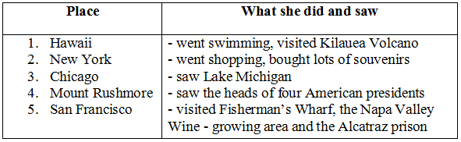

**2. Answer the following questions.**

**a)** How did Mrs. Quyen go to Kilauea Volcano?

=> She went there by plane.

**b)** Where in San Francisco did Mrs. Quyen see the famous prison?

=> She saw the prison on the island of Alcatraz.

**c)** What is special about Mount Rushmore?

=> People can see Mount Rushmore from more than 100 kilometres away.

**d)** What is the other name of Chicago?

=> It is also called "The Windy City".

**e)** What did Mrs. Quyen do while her husband was visiting the Statue of Liberty?

=> She went shopping.