**UNIT 13 : FESTIVALS**

**SECTION: WRITE** (Trang 126-127 SGK Tiếng Anh 8)

*I. OBJECTIVES*

By the end of the lesson, students will

- be able to write a report of an event

- develop writing skill

***II. LANGUAGE CONTENT***

**\* Grammar**:

- *Revision of* *Simple Past tense: Active & passive forms*

**\* Vocabulary**:

- *(n) yard, competitions, contest, husk, points*

*- (adj) communal,*

*- (v) win, rub*

*III. CONTENTS :*

**1. Use the information in the dialogue on page 121 to fill in the gaps in this report.**

**(Sử dụng thông tin ở hội thoại trang 121 để điền vào chỗ trống trong bản báo cáo này.)**

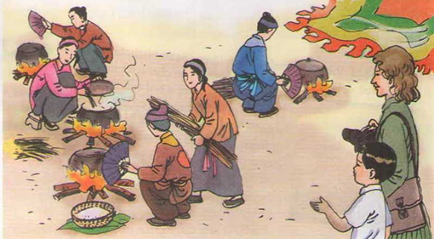

**Gợi ý:**

This report shows how the (1) **rice-cooking**festival was held.

The festival was held in the communal house yard about (2) **one kilometer** away from a river. There were three competitions: (3) **water-fetching**, fire-making and rice-cooking. The festival took one day.

In the water-fetching contest one person from each team had to (4) **run**to the river to get the (5) **water**.

In the fire-making contest two team members had to make a fire in the (6) **traditional** way. They tried to rub pieces of (7) **bamboo** together to make the fire.

(8) **Six** people from each team took part in the rice - cooking contest. They had to (9) **separate** the rice from the husk and then cook the rice.

After the three contests, all points were (10) **added** and the Thon Trieu group won the grand prize. The festival was wonderful.

**2. Write a similar report on a festival you joined recently. The answers to the questions below can help you.**

**(Hãy viết một bản báo cáo tương tự về một lễ hội em mới tham gia. Những câu trả lời của những câu hỏi dưới đây sẽ giúp em.)**

**Bản báo cáo tham khảo:**

**The Huong Pagoda festival**

This report shows how the Huong Pagoda festival is held.

The Huong Pagoda and the Huong Tich cave are the famous scenic spots of Viet Nam. The Huong Pagoda festival lasts from the 6th day of the 1stmonth to the end of the 3rd month of the lunar calendar. People conduct dragon dance in the yard of Trinh pagoda and sail the royal barge. The festival is held in 3 places: Huong Tich, Tuyet Son, Long Van. The festival is most crowded from the 15th - 20th day of the 2ndmonth of the lunar calendar as this period marks the main festival. The mountainous path leading from Ngoai pagoda to Trong pagoda is full of visitors coming up and down. A pilgrimage to the Huong Pagoda is not only for religious reasons but also to see the numerous natural shapes that are typical of the landscape and the buildings that are valuable artifacts of the nation.

Từ vựng:

Barge (n): xuồng, xà lan, thuyền rồng

Pilgrimage (n): cuộc hành hương