**TRƯỜNG THCS PHAN CÔNG HỚN**

**TỔ TIẾNG ANH - TIẾNG ANH 9**

**TUẦN 32 (TỪ 21/4 ĐẾN 26/4 )**

**WEEK 32**

**PERIOD 94-95-96**

**Lesson 2.1**

**NEW WORDS**

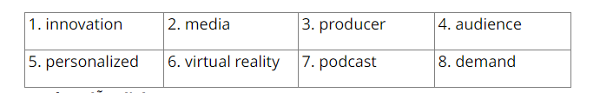

**READING**

a/ 2. how technology will affect jobs in the media

b/

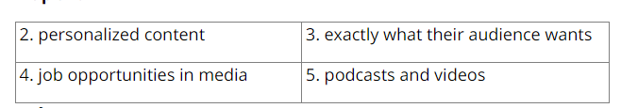

**GRAMMAR**

a/ expect to watch

c/

2. working => work

3. using => to use

4. get => to get

5. hiring => to hire

6. complete => to complete

7. seeing => to see

8. being => to be

**d/**

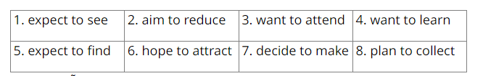

**SỬA BÀI TẬP TUẦN 31**

**UNIT 8 : JOBS IN THE FUTURE**

**LESSON 1-1 (New Words)**

**III. Choose the word or phrase (A, B, C or D) that best fits the space in each sentence.**

1. I meet a _____________ every week to talk about my feelings and problems.
2. plumber B. mechanic **C. psychologist** D. tutor
3. I want to be a(n) ______so I can help people look nice. Having clean and soft skin can help them feel confident.
4. plumber **B. skincare specialist**  C. psychologist D. tutor
5. I damaged my car. I hope the _____________ can fix it.
6. **mechanic** B. skincare specialist C. psychologist D. tutor
7. I need a(n) _____________ for math. They could help me get better grades.
8. plumber B. skincare specialist C. psychologist **D. tutor**
9. I use the internet to _____________ and find information to help me choose a future job.
10. repair B. help **C. research** D. fix
11. I think I should find a(n) _____________ and learn how to do a job that way.
12. plumber B. skincare specialist C. psychologist **D. apprenticeship**
13. Water is coming out of the bathroom. Can you call a(n) _____________, please?
14. **plumber** B. skincare specialist C. psychologist D. tutor
15. I want to become a _____________. I think helping people feel better would be great.
16. plumber B. skincare specialist **C. psychologist** D. tutor
17. Being a _____________would be interesting. I love making my face and skin look nice.
18. plumber **B. skincare specialist**  C. psychologist D. tutor
19. Being a _____________would be interesting. I like fixing cars and making them run well.
20. plumber **B. mechanic**  C. psychologist D. tutor
21. I think I'd find being a _____________interesting. I like helping people understand things better.
22. plumber B. mechanic **C. psychologist** D. tutor
23. Doing _____________would be interesting. I like finding out new things and learning more.
24. plumber B. skincare **C. research** D. tutor
25. If you want to get better grades, you should get a **__________.**
26. plumber B. skincare C. research **D. tutor**
27. I’m not good _____ math, so I want to find a tutor.

**A. at** B. on C. in D. of

1. I think I would be better at being a ____________because I love cars and motorbikes.
2. plumber **B. mechanic** C. psychologist D. tutor
3. Miss White: Hi, Miss White. _____________________________. I appreciate it.

Paul: You're welcome. So what jobs are you interested in?

1. **Thanks for helping me.**
2. That’s not a bad idea.
3. Sounds great.
4. I understand what you’re saying.

17. Pham Tuan was the first Vietnamese__________ to fly in space in 1980.

A. plumber B. mechanic C. psychologist **D. astronaut**

18. If Mary wants to improve her grades in math, she should find a _________________.

A. plumber B. mechanic C. psychologist **D. tutor**

19. Mike : “ I want to be a fashion designer.”

Lina : “_______________________”

**A. That’s a good idea!** B. No problem .

C. Thank you D. Let’s go!

20. Paul : “I want to be an astronaut.”

Sofia : “_________________________________”

**A. If you want to be an astronaut, you should get fit.** B. No problem.

C. Because we expect to see more jobs. D. I appreciate it.

21. Gina : “If you want to be a mechanic, you should take a short course .”

Polly : “___________________________________”

A. Sorry, no thank you. **B. That’s a good idea. I appreciate it.**

C. What do you mean? D. I should get a tutor.

**IV. *Use the correct form of the word given in each sentence.***

**1. plumber**

**2. psychologist**

**3. mechanic**

**4. specialist**

**5. apprentice**

**6. researcher**

**7. mechanical**

**8. mechanical**

**9. psychological**

**10. psychologists**

**11. tutors**

**12. apprenticeship**

**13. apprentices**

**14. mechanical**

**15. mechanically**

**UNIT 8 : JOBS IN THE FUTURE**

**LESSON 1-2 (Grammar)**

**Give correct form of the verbs**

1. **studies**
2. **practices**
3. **rains**
4. **want**
5. **is / go**
6. **save**
7. **doesn’t feel / see**
8. **will be**
9. **go**
10. **wants**