**Week: 2**  **Planning date: 13-18/9/2021**

**Period: 4**

**UNIT STARTER**

**LESSON 3: VOCABULARY**

**I/ VOCABULARY:**

1. Poster (n)
2. Drawer (n)
3. Mobile phone (n)
4. Clock (n)
5. Dictionary (n)
6. Coat (n)
7. Laptop (n)

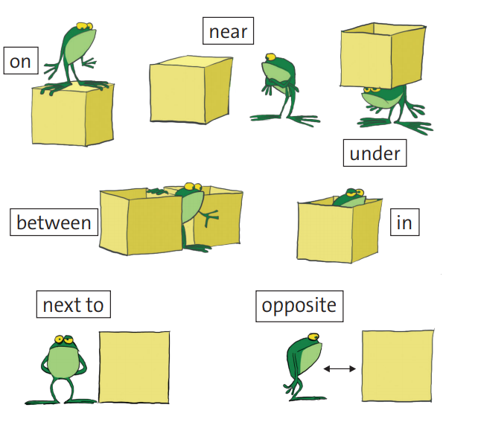**II. PREPOSITION:**

1. The dictionaries are _______the shelf.

2. The teacher’s mobile is ______ the drawer.

3. The laptop is __________ the speakers.

4. The students’ chairs are _____ their desks.

5. The poster is ________ the teacher’s table.

6. Harry’s coat is _______ his chair.

7. Eva’s bag is ________ her desk.

8. The clock is ________ the board.

9. The board is _______ the students’ desks.

10. Harry’s pen is _________ his notebook.

**III. HOMEWORK:**

* Learn by heart all the new words.
* Workbook (6)
* Prepare Lesson 4

**Week: 2**  **Planning date: 6-11/9/2021**

**Period: 5**

**UNIT STARTER**

**LESSON 4: LANGUAGE FOCUS: POSSESSIVE ‘S – “BE” QUESTIONS – POSSESSIVE PRONOUN**

1. **POSSESSIVE ‘S:**

|  |  |
| --- | --- |
| **RULES** |  |
| **1** We use ***'s*** for possession with | _singular___words. (số ít) |
| **2** we use ***s'*** for possession with | ____plural________words. (số nhiều) |

* Do exercise 2/ page 9

1. **“BE” QUESTIONS:**

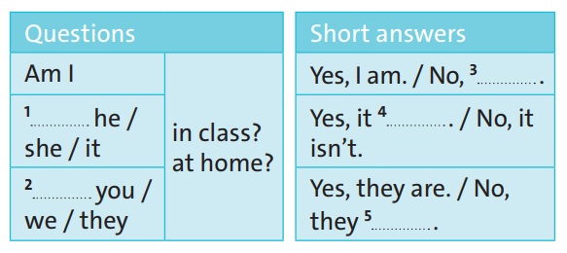

1. Is 2. Are 3. I’m not 4. is 5. aren’t

**III, POSSESSIVE PRONOUNS**

|  |  |  |
| --- | --- | --- |
| **Subject Pronouns** | **Possessive** | |
| **Adjectives** | **Pronouns** |
| **I** | **my** | **mine** |
| **you** | **your** | **yours** |
| **he** | **his** | **his** |
| **she** | **her** | **hers** |
| **it** | **its** | **its** |
| **we** | **our** | **ours** |
| **you** | **your** | **yours** |
| **they** | **their** | **theirs** |

**HOMEWORK**

1. Learn new words and grammar of today’s lesson.
2. Workbook (page 7)

**Week: 2**  **Planning date: 13-18/9/2021**

**Period: 5**

**UNIT STARTER**

**LESSON 5: VOCABULARY – BASIC ADJECTIVE**

**I/ VOCABULARY:**

|  |  |  |  |  |  |
| --- | --- | --- | --- | --- | --- |
|  |  | **Position of Adjective**  (Vị trí của tính từ) | |  |  |
|  | |  |  |  |  |
| After to be (Sau “to be”) | |  |  | Before nouns (Trước danh từ) | |
| To be + Adj | |  |  | Adj + noun | |
|  |  |  |  |  |  |

|  |  |  |  |  |  |  |  |  |
| --- | --- | --- | --- | --- | --- | --- | --- | --- |
|  |  | really |  |  |  |  |  |  |
|  |  |  |  |  |  |  |  |  |
| **Adverbs of degree** |  | very |  |  |  |  |  |  |
| (Trạng từ chỉ tần suất) |  |  |  |  |  |  |  |  |
|  |  | quite |  |  |  |  |  |  |
|  |  |  |  |  |  |  |  |  |

1.This film is *quite* **boring.**

2. My dad's laptop is *very* **expensive.**