**EXERCISES – TUẦN 10**

|  |
| --- |
|  |

**I. Reading Comprehension :**

**@. Look at the ticket, and decide whether the statements that follow are True or False. (1 pt)**

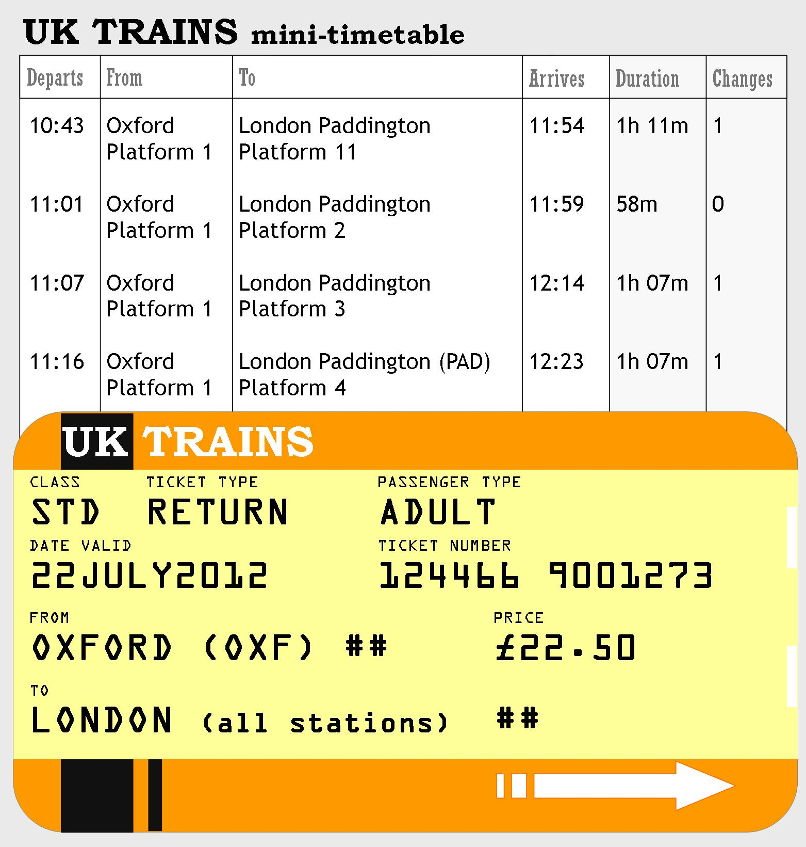

6. The ticket is for trains from Oxford. __________

7. You don’t have to change train if you take the 11:07 train. __________

8. The ticket is for children only. __________

9. With this ticket you can go to any stations in London. __________

**@@. Choose the word or phrase that best fits the blank space in the following passage.**

|  |
| --- |
| Every day I get up at six and I have breakfast ___(10)___ home. My parents usually drive me to school ___(11)___ car, then they come to their office near my school. We rarely have lunch at home because I have to study in the afternoon. After work, my father and I like to play __(12)__ in the sport club, but my mother likes to cook dinner for us at home. I often __(13)__ my homework at 9 PM. Then we watch TV together in the living room before __(14)__ to bed at 10:30. |

|  |  |  |  |
| --- | --- | --- | --- |
| 10. A. in | B. on | C. at | D. from |
| 11. A. on | B. by | C. in | D. of |
| 12. A. volleyball | B. basketball | C. football | D. all are correct |
| 13. A. finish | B. make | C. help | D. all are correct |
| 14. A. go | B. to go | C. going | D. went |

**II. USE OF ENGLISH :** Choose the word or phrase that best fits the blank space.

|  |  |  |  |  |
| --- | --- | --- | --- | --- |
| 15. Where is your school? It is _____ Ly Tu Trong street. | | | |  |
| A. on | B. at | C. to | D. in | |
| 16. Talking to friends ________ a good way to relax. | | | |  |
| A. are | B. is | C. do | D. A and B are correct. | |
| 17. There are _____apples in the fridge. But there aren’t _____ bananas. | | | |  |
| A. any/any | B some/some | C. some/any | D. any/some | |
| 18. _________ an expensive pair of scissors. | | | |  |
| A. This | B. That’s | C. These are | D. Those are | |
| 19. What time is it? It’s _____ (10:15). | | | |  |
| A. ten fifteen minutes | B. quarter past ten | C. a quarter to ten | D. fifteen to ten | |
| 20. What ______ those women? ______ famous singers. | | | |
| A. is/ She is | B. is/ They’re | C. are/ They’re | D. are/ She’s | |
| 21. Six miles _________ a long way to walk every day. | | | |
| A. is | B. are | C. do | D. don’t | |
| 22. What are _____________ jobs? | | | |
| A. Tom sisters | B. Tom’s sisters | C. Tom’s sisters’s | D. Tom’s sisters’ | |
| 23. ________ do you brush your teeth every day? __ I brush my teeth carefully. | | | |
| A. Why | B. What | C. How | D. How often | |
| 24. ___________ notebooks do we need for English? | | | |
| A. How | B. How much | C. How many | D. When | |
|  | | | | | |

**III.**

**A. Make the questions with the words underlined.**

|  |
| --- |
| 1. We often meet **our friends** on Saturday. |
| ☞ ……………………………………………………………………………………………………………………………… |
| 2. My father usually has beefsteak for his breakfast **because he wants to be healthy**. |
| ☞ ………………………………………………………………………………………………………………………………  3. There is **one** big bed in my bedroom.  ☞ ……………………………………………………………………………………………………………………………… |

**B. Rewrite the second sentence so that it has the same meaning as the given one.**

|  |
| --- |
| 1. Let’s go out for a drink! |
| ☞ **How** ……………………..……………………………………….? |
| 2. That film is interesting. |
| ☞ **That is** ……………………………….…………………………. |