**PHIẾU HƯỚNG DẪN HỌC SINH TỰ HỌC**

**MÔN: TIẾNG ANH 6 – TUẦN 18**

**Tiết 52,53,54**

**FURTHER PRACICE 4-5-6**

**Phiếu hướng dẫn học sinh tự học**

|  |  |
| --- | --- |
| **NỘI DUNG** | **GHI CHÚ** |
| **Tên bài học/ chủ đề - Khối lớp** | **Tiết 52,53,54**  **FURTHER PRACICE 4-5-6** |
|  | - Đọc và làm các phần trong Further practice 4-5-6  - Xem lại phần grammar đã học để củng cố kiến thức. |
| **Hoạt động 2**: ***Kiểm tra, đánh giá quá trình tự học.*** | **Exercise:**  1.I ________ to the park on the weekends.  A.sometimes go B.go sometimes C.sometimes goes D.goes sometimes  2.He likes_________ soccer with his dad.  A.play B.plays C.playing D. to play  3. What are you going to do _____ Saturday?  A.in B.on C.at D.for  4. I don’t like biology, math______ music.  A.and B.with C. or D.for  5. What time _______ the party ______?  A.does/end B.do/end C.does/ends D.do/ends  6. I often eat cơm tấm with_______on top.  A.soup B.meat C.fish sauce D.rice  7. J.K.Rowling is a famous _________. She wrote the Harry Potter series.  A.novel B.teacher C.teacher D.author  8._______you often go shopping with your mother?  A.Do B.Does C.What D.Where  9. What would you like _______?  A.eat B.to eat C.eating D.eats  10.He______ tall and _____ short black hair.  A.is/have B.are/has C.is/has D.are/have |

**Bài ghi học sinh**

**FURTHER PRACICE 4,5,6**

**FURTHER PRACTICE 4**

**I.Choose the word whose underlined part pronounced differently from the others**

1. A. misses    B. stops     C. rises     D. teaches

2. A.buses B.boxes     C.eats                    D.watches

3. A. beach B. meat C.read D.head

4. A.subject B.under C.sunny D.helpful

**II. Choose the most suitable word to fill the blanks.(circle A, B, C, or D)**

1. Ho Chi Minh city is an the ____________ of Vietnam.

A. north B.south C.west D.east

2. ____________ people don’t like sharing or giving to other people.

A. lazy B.funny C.selfish D.kind

3. I have milk, eggs, flour and sugar. Let’s _____________.

A. go to the beach B.watch TV C. have a party D. make a cake

4. I don’t like running and playing sports. I don’t like __________.

A. P.E B. literature C.I.T D.biology

5. What time _______ the festival __________?

A. do/start B.does/start C.do/starts D.does/starts

6. Julie ___________ yoga after school.

A. usually do B.do usually C.usually does D.does usually

7. He _____________ soccer on Saturday.

A. plays B.is playing C.to play D.are playing

8. Why don’t you sign up __________ the book club?

A. of B. for C. in D. at

9.What are you doing _________ the weekend?

A. at B.in C.at D.on

10. I like math, biology, ________ music.

A.and B.in C.at D.or

11. *Emma*: How often do you go to the gym?

*Toby*: ________________________.

A. Not really B. Twice a week C. No matter, please D. Not at all

12. *Nam:* What subject do you like best?

*Lan: _____________________.*

A. My favorite subject is English B.I like Harry Potter

C. I don’t like literature. D. I have math on Monday.

**III.Read the signs and choose the best answer**

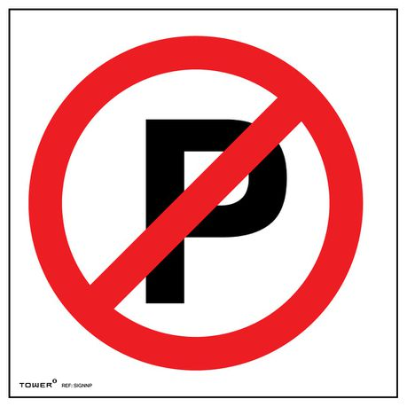1.What is the meaning of this sign?

A.Roundabout.

B.No parking.

C.No turn right.

D.Go straight ahead.

2.What is the meaning of this sign?

1. No dancing.
2. No cooking.
3. No eating and drinking.
4. No swimming.

**IV. Match the questions in column A to the answers in column B**

|  |  |
| --- | --- |
| **A** | **B** |
| 1.What is he like ? | A. At 8.30 a.m. |
| 2.Where do you live ? | B. He is kind and funny. |
| 3.What time does the food stand start? | C.I live in an apartment. |
| 4.How often do you play soccer? | D.I rare play soccer. |
| 1…………… 2………………. 3…………………. 4………………. | |

**V. Reading**

**1/** **Read the passage and choose A, B, C or D to complete each gap:**

My favorite novel (1)______ *Five Point Someone*. It is an Indian novel. The (2)______ is Chetan Bhagat. The Story is (3)______ three students, Farhan, Raju, and Ranchoddas.

They (4)______ hard and become successful after finishing school. They help each other a lot. This shows people that they can (5)______ new things anywhere. People then made the novel into a popular Indian movie called 3 Idiots in 2009. Millions of young adults (6)______ teenagers love the novel and the movie.

1. A. is B.are C.have D.be

2. A.character B.author C.singer D.actor

3. A.of B.with C.about D.on

4. A. works B.to work C.work D.working

5. A. learn B.learning C.to learn D.learns

6. A.or B.and C.of D.with

**2. Read the passage carefully then decide the statement is true or false**

**School club**

We have lots of fun club at our school. If you like outdoor activities, the Soccer Club meets at 4p.m every Tuesday, with the Tennis Club at the same time on Thursday. For indoor activities, the Board Games Club starts next week. It Is popular so please sign up on the noticeboard. The Book Club welcomes anyone who likes reading. You don’t need to sign up but please bring your own copy of The Secret Garden with you to the Library at 4 p.m on Wednesday. Our Arts and Crafts Club is for people who like making thing. The cost is $20 per term for materials.

1. The Soccer Club is on Tuesday.

2. You need to sing up on the noticeboard for the Board Games Club .

3. You don’t need to sign up for the Book Club.

4. The Arts and Crafts Club don’t need money.

1……….. 2………. . 3…………… 4…………..

**VI. Rewrite:**

1. always/ goes to/ My mom/ after work. /supermartket

__________________________________________________________________

2. How/ people/ do/for/prepare/ Christmas? ____________________________________________________________________

3. Mary/ tall/ has/ blond hair./ is

_______________________________________________________________

4.He has short hair.

=>His hair __________________________________________________________.

5. What is your favorite subject?

=> What ___________________________________________________________?

**FURTHER PRACTICE 5**

**I.Choose the word whose underlined part pronounced differently from the others**

1. A. talks     B. takes     C. decides     D. completes
2. A. months     B. books     C. pens     D. shirts
3. A.funny B.shy C.fantasy D.mystery
4. A.east B.feast C.weather D.repeat

**II. Choose the most suitable word to fill the blanks.(circle A, B, C, or D)**

1. It’s a beautiful day! Let’s _____ and swim in the sea .

A.go to the mall B.go to the beach C. make a pizza D. watch TV

2 I love to learn how light, heat, and sound work. I love ______ .

1. Geography B.biology C.physics D.math

3. We’re out of juice. Can you buy some when you ___________ ?

A. do the laundry B. do the dishes C.clean the bathroom D. do the shopping

4.______ people make their friends laugh.

A. funny B. friendly C.lazy D.selfish

5. Julie ________ hopscotch with her friends in the park.

A. sometimes play B. sometimes plays C. play sometimes D. plays sometimes

6. What hosework ____ your sister _____?

A. do/ do B.does/does C.does/do D.do/does

7. What is she wearing? She ________ a pink hat and a yellow sweater.

A. wears B.wear C.are wearing D. is wearing

8. This city is famous ______ beautiful houses and museums.

A. of B. for C. in D. at

9. My brother is going shopping _________ Friday.

A. at B.on C.at D.in

10. I don’t like geography, literature, ______ physics.

A.and B.in C.at D.or

11. *Tuan*: Excuse me, Xuan. Where do you live?

*Xuan*: ___________________.

A. I live with my parents B. At a shopping center

C. No, with my friends D. I live in District 9

12. *Adrian*: Excuse me, Alex. Do you live in a house?

*Sarah*: No, _________. I live in an apartment.

A. I doesn’t B. I don’t C. It is not D. I am not

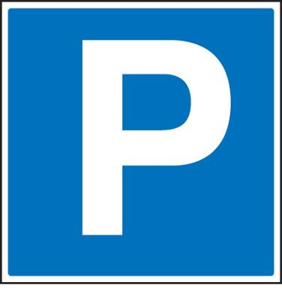**III.Read the signs and choose the best answer**

1. What is the meaning of this sign?
2. You can park here. C.You can go ahead.
3. You can’t not go ahead. D.You can’t park here.
4. What is the meaning of this sign?
5. No dancing.
6. No cooking.
7. No eating and drinking.
8. No swimming.

**IV. Match the questions in column A to the answers in column B**

|  |  |
| --- | --- |
| **A** | **B** |
| 1.What’s your favourite book? | A. It’s by J.K. Rowling. |
| 2.Who’s the author? | B. She is tall and has long blond hair. |
| 3.What does she look like? | C.I like Harry Potter and the Sorcerer’s Stone. |
| 4.Is he wearing glasses? | D. No, he isn’t. |
| 1…………… 2………………. 3…………………. 4………………. | |

**V. Reading**

**1/** **Read the passage and choose A, B, C or D to complete each gap:**

**My Favorite novel**

Thành Nguyễn, November 18

My favorite (1)______ is *Yellow Flowers on the Green Grass* ( tôi thấy hoa vàng trên cỏ xanh) . It’s an interesting novel. The (2)______ of the book is Nguyễn Nhật Anh. The book is (3) ______ Thiều and people around him. I like the book because it shows us many beautiful thing in Thiêu’(4) ______. It is a peaceful village with green grass, trees, wind, and yellow flowers. Some parts of the story (5) _____ sad. I cried a lot when I thought Thiều’s brother can not walk again. . I really like this book. I think you should (6)______ it.

1. A.book B.subject C.food D. color

2. A. character B.author C.singer D. actor

3. A.about B.on C.in D.of

4. A. school B.village C.city D.town

5. A. is B.are C.have D.has

6. A. read B. reads C.reading D.to read

**2/Read the passage carefully then decide the statement is True or False**

**A famous festival in Vietnam**

In Vietnam, people celebrate many different festivals each year. The biggest festival in Vietnam is Tet. This celebrates the beginning of the Lunar New Year. Vietnamese people have to prepare a lot of this festival. Before Tet, people buy fruits and flowers from the market and decorate their house. Most people buy special tree with lots of flowers. In the north of Vietnam, people buy peach tree with pink flowers. In the south of Vietnam,people buy apricot tree with yellow flowers. Everyone cleans their house before Tet.This is very important because you shouldn’t clean it during Tet. During Tet, people visit their family and friends. Few people go to school or work. Children wear new clothes and get lucky money. It’s the great time to watch lion dance and fireworks. Everyone is happy and excited about the New Year. Vietnamese people love to celebrate this festival.

1. People buy fruits and flowers during Tet.

2. Every house has the same type of tree.

3. People clean their houses during Tet.

4. You can watch lion dances during Tet.

**VI. Rewrite:**

1. I’m/ a/ barbecue/ on/ the weekends. / having

______________________________________________________________________

2. Mary/ tall/ has/ blond hair./ is

______________________________________________________________________

3.What about having a barbecue this weekend?

=>Let’s ______________________________________________________________

4. What subject do you like?

=> What’s ___________________________________________________________

**FURTHER PRACTICE 6**

**I.Choose the word whose underlined part pronounced differently from the others**

1.A. styles B. clothes C. sides D. sizes

2.A. songs B. cloths C. cuffs D. silks

3.A. funny B.blue C.true D.glue

4.A. beach B. meat C.read D.head

**II. Choose the most suitable word to fill the blanks.(circle A, B, C, or D)**

1/Studying _________ helps me learn about countries around the world and famous people in the past.

A. music B.history C.biology D.P.E

2. My grandmother usually ________ early to go jogging around the park.

A. gets up B. got up C. get up D. will get up

3.I have two _______ and they ______ students at primary school.

A. brothers/is B. brother/are

C. brothers/are D. both a and b are correct

4._________you often go shopping with your mother?

A. Do B. Does C. What D. Where

5.The train leaves ______ 4.45 p.m.

A. on B.for C.at D.in

6. Does the café open _____ the morning?

A.in B.of C.on D.at

7.*Emma*: How often do you go to the gym?

*Toby*: ________________________.

A. Not really B. Twice a week C. No matter, please D. Not at all

*8.Hugo*: What does your father do?

*Stephen*: ______________________.

A. Well, I do gym B. He is an English teacher C. No, I do not know D. Why not?

**III.Read the signs and choose the best answer**

1.What is the meaning of this sign?

1. 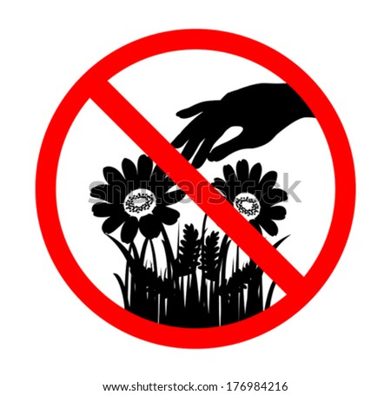Please pick up flower.
2. Don’t walk on the grass.
3. Please walk on the grass.
4. Don’t pick up flower.

2. What is the meaning of this sign?

1. Ahead only.
2. No turn left.
3. No entry.
4. No U-turn.

**IV. Match the questions in column A to the answers in column B**

|  |  |
| --- | --- |
| **A** | **B** |
| 1.Do you like literature? | A.I like biology, physics, and literature. |
| 2.Which club is on Tuesday? | B.No, I don’t. |
| 3.What’s your favourite subject? | C.Sure, here you are. |
| 4. Do you have a ruler? Mine is at home. | D.The soccer club. |
| 1…………… 2………………. 3…………………. 4………………. | |

**V. Reading**

**1/** **Read the passage and choose A, B, C or D to complete each gap:**

**My Favorite novel**

Thành Nguyễn, November 18

My favorite (1)______ is *Yellow Flowers on the Green Grass* ( tôi thấy hoa vàng trên cỏ xanh) . It’s an interesting novel. The (2)______ of the book is Nguyễn Nhật Anh. The book is (3) ______ Thiều and people around him. I like the book because it shows us many beautiful thing in Thiêu’(4) ______. It is a peaceful village with green grass, trees, wind, and yellow flowers. Some parts of the story (5) _____ sad. I cried a lot when I thought Thiều’s brother can not walk again. . I really like this book. I think you should (6)______ it.

1. A.book B.subject C.food D. color

2. A. character B.author C.singer D. actor

3. A.about B.on C.in D.of

4. A. school B.village C.city D.town

5. A. is B.are C.have D.has

6. A. read B. reads C.reading D.to read

**2/Read the passage carefully then decide the statement is True or False**

**Good sister, bad sister**

***Tâm Trần, June 21***

One of my favorite stories is from Vietnam. It’s about two sisters, Tấm and Cám. The two sister are very different. Tấm works hard every day helping to cook and clean the house. She always thinks about other people and tries to help her family. Cám is very different to Tấm. She never does any chores and she doesn’t share anything. Cám does lots of bad things to Tấm. It’s not a nice story, but in the end, Tấm’s life is very good. I like the story because after such a hard life she is happy.

1. Tấm helps to cook and clean the house.

2. Tấm never thinks about other people.

3. Cám is the same to Tấm.

4. Cám does a lot of bad things to Tấm.

**VI. Rewrite:**

1. sometimes/ He/ plays/ soccer.

………………………………………………………………………………

2. What time/ end ?/ the festival/ does

………………………………………………………………………………

3. How/ people/ do/for/prepare/ Christmas?

………………………………………………………………………………

4. Let’s go to the beach on Sunday.

=> What about________________________________________________.

5. What is your favorite subject?

=> What subject_______________________________________________?