ĐỀ CƯƠNG KIỂM TRA GIỮA KỲ II MÔN TIẾNG ANH 9
I.Chọn đáp án đúng nhất để hoàn tất câu:

1. Plastic bags are very hard to ………, so they will cause pollution.( dissolve, reuse, throw, drip)
2. I’m …………………. that people have spoiled this area. (happy, glad, disappointed, serious)
3. Will you turn ……….. the TV, please ! I want to watch the weather forecast. (on, of, off, in)
4. Polluted water can directly ……………….. to our health and kill fish. (reuse, save, do harm, suggest)
5. Plastic bags seem good for carrying things……………, people carelessly throw them away after use. (Because
However, Although, Therefore)
6. You should reduce ……………..of water your family uses. (the number, the quality, a number, the amount)
7. “I suggest we go on a picnic on the other side of the river.” – “………………”(It’s a nice day / Have a good trip / Great idea / Congratulations!)
8. If the rice paddies are polluted, rice plants……………(will die / would die / won’t die / wouldn’t die)
9. Let’s get a …………to make sure there are no cracks in the pipes. (teacher / electrician / plumber / carpenter)
10. …………the Thi Vai River is awfully polluted, its water is not fit for fish to survive.( So, Although, Since, If)
11. The teacher suggests ……………….something for the poor in our area.( us to do, we should do, we are doing,
we will do)
12. …………….is a piece of land full of rubbish. (junk-yard, stream, hedge, treasure)
13.………………..reducing water pollution? (Why not, Why don’t you, Won’t you, what about)
14. “ It’s a lovely day. Shall we go for a walk?” “ …….” (No problem / OK / you’re right / enjoy yourself)
15. Remember to turn off the …………….or you will pay much every month. (bill, faucet, solar energy, roof)

II.Viết tiếp câu với từ gợi ý sao cho nghĩa không thay đổi
1. You use more energy-saving bulbs. It costs you less money.
If ………..……………………………..…………………………………………………………………… .
2. We pollute the water. We have no fresh water to use.
If ………………………………………………………………………………………………………………..
3. “ Why don’t you go to school by school bus, Ba?” .
I suggest that …………………………………………………………………………………………………….
4. I think we should you stop here.
I suggest ……………………………………………………………………………………………………….
5. I’m trying to find my book .
I’m trying to look…………………………………………………………………………………………………
6. Hanh is taking care of her baby at home.
Hanh is looking ……………………………………………………………………………………………………
III. Sắp xếp từ thành câu hoàn chỉnh
1. / make this beach a clean / we will / and beautiful place again / If we work hard, /
If …………………………………………………………………………………………….
2. recent water bill / I’m about my most / worried
I’m ……………………………………………………………………………………………
3. of water a month / faucet can / waste 500 litters / A dripping
A dripping …………………………………………………………………………………….
IV.Cho dạng thích hợp của từ trong ngoặc để hoàn tất câu
1. Air …………………… is one of the main reasons causing greenhouse effect. (pollute)
2. Mr Brown is ……………….kind with others. (extreme)
3. This energy-saving bulb works very …………………… .It consumes less electricity. (effective)
4. It was believed that our ……………… resources could never be used up. (nature)
5. ………………..want to conserve the Earth’s resources. (environmental)
6. She is ……………… that she has failed the test. (disappoint)
7. The water in this river is very………………… (pollute)
8. The wild animals love to live in …………………. (natural)

III.Reading
A. Đọc đoạn văn sau và trả lời đúng (TRUE), hay sai (FALSE). Sau đó chọn đáp án đúng cho câu 5,6
We are all destroying the Earth. The seas and rivers are too dirty to swim in. There is so much smoke in the air that it is unhealthy to live in many of world’s cities. In one well- known city, for example, poisonous gases from cars pollute the air so much that policemen have to wear oxygen masks. We have cut down so many trees that there are now vast areas of waste land all over the world. As a result, farmers in parts of Africa can not grow enough to eat. In certain countries in Asia there is so little rice. Moreover, we donot take enough care of the countryside. Wild animals are quickly disappearing. For instance, tigers are rare in India now because we have killed too many for them to survive. However, it isn’t enough simply to talk about the problem. We must act now before it is too late to do anything about it. Join us now. Save the Earth.
1. It is very healthy to live in a city now. ……………..
2. In popular city, policemen wear oxyzen masks because of poisonous gases. ……………..
3. There is a lot of waste land in the world nowadays. ……………
4. Farmers produce enough rice for their life. …………….
5. What is the main idea of the passage?
a. Conservation b. Protect the nature c. The environment d. Save the Earth
6. It can be inferred from the passage that ……………
a. Tiger is slowly disappearing. b. People like to live in big cities.
c. Most countries in Asia are rich. d. People killed many wild animals.

B. Circle the word a, b, c, d and complete the blank in the passage
In Western countries, electricity, gas and water are not luxuries but (1)…………... Companies now realize that consumers want products (2) … will both work effectively and save money. For most North American households lighting accounts (3) … 10 percent to 15 percent of the electricity bill.(4)……………, this amount can be reduced by replacing an ordinary 100-watt light bulb with an energy saving bulb. These bulbs use a quarter of the electricity of standard bulbs and last eight times (5)……………..Therefore , consumers (6)…………….save about US$7 to US$21 per bulb.

1. a. necessary b. necessarily c. necessity d. need
2. a. who b. when c. that d. where
3. a. for b. at c. in d. on
4. a. However b. Therefore c. Although d. Moreover
5. a. longer b. cheaper c. bigger d. smaller
6. a. could b. can c. should d. would

 | 1a. Students can sit here  b. Chairs for the disabled.  c. Sports for disabled people.  d. Chairs for the boy only. |  | 2. What does this sign mean?  a. You can park here.  b. You can’t park here.  c. No right turn.  d. No left turn.
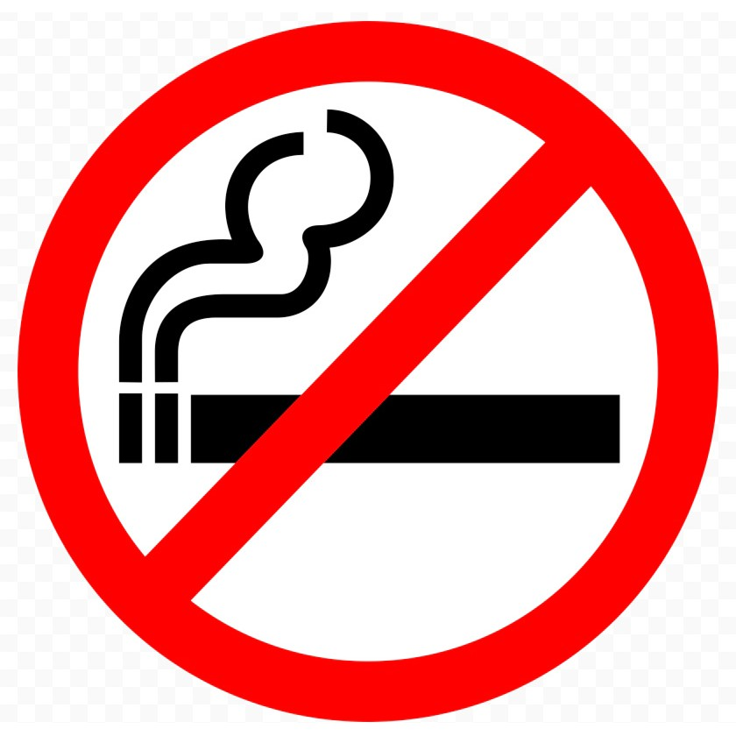 | 3. a. You can’t smoke here  b. You can’t take photos here.  c. You can’t swim here.  d. You can’t park here. |  | 4. a. There is a museum ahead.  b. There is a hotel ahead.  c. Visitors can buy food here.  d. There’s a hospital ahead.

CÁCH PHÁT ÂM “ S, ES”
“S/ES”
Có 3 cách phát âm: /s/, /iz/, /z/
/s/: k, p, f, t, th (khắp phố “fường” tối thui) Ex: books, cups, cats, laughs
/iz/: sses, ches, xes, shes, ges, ces…..
(sáng sớm chạy xe SH gặp chim sẻ) Ex: washes, kisses, teaches, boxes….
/z/: còn lại Ex: kids, days, keys, apples, countries
Đặc biệt:
“gh” phiên âm là “f”: laugh, cough, tough, rough nên ta cho vô trường hợp /s/

Exercises: Find the word that has the underlined part pronounced differently from the others
1. A. proofs B. books C. points D. days
2. A. helps B. watches C. arranges D. misses
3. A. neighbors B. friends C. relatives D. books

Exercises: Find the word that has the stress syllable pronounced differently from the others

1. A. garbage B. pollute C. reduce D. replace
2. A. consumer B. pesticides C. dynamite D. energy
3. A. pollution B. effective C. natural D. resources

I.Từ gia đình: III. Công thức:
1. pollute (v) gây ô nhiễm 1. CÂU ĐỀ NGHỊ:
- pollution (n) sự ô nhiễm - Why don’t you
- polluted (adj) bị ô nhiễm # unpolluted = Why not
2.disappoint (v) buồn, chán = Shall we + V
- disappointed / disappointing (adj) “”
- disappointment (n) = Let’s
3. effect (v) kết quả = I think you should
- effective (adj) có hiệu quả = It would be better if you
- effectively (adv) “”
4. nature (n) thiên nhiên = How/ What about + V-ing
- natural (adj) “”
- naturally (adv) “” 2. Công thức if
5. extreme (adj) rất, đáng kể If + S + Vhtại, S + will + V….
- extremely (adv) “” ( V/ Vs,es )
6. environment(n) môi trường be: is, am, are
- environmental(adj) “” 3. sau: stop, spend, like, enjoy, look forward to
- environmentally(adv) “” …… là V-ing
- environmentalist(n) Sau giới từ: in, on, at of, for, with, by, from, …là V-ing
II. Cụm động từ 6. suggest + V-ing
(đề nghị) + (that) + S + should + V
- look for = find (v) tìm thấy
- look after = take care of (v) chăm sóc
- go on = keep on (v) tiếp tục

