**UNIT 2 : SCHOOL**

**PERIOD 1: New words- Listening-Grammar**

* **Pronunciation ( page 14,15,16)**

Lesson 1 : Can you ….. ?

* Talk about school subjects you like or don’t like.
* Use “and” and “or” for positive and negative statement.
* Use Possessive Pronouns.

1. **NEW WORDS :**

history (n)  /ˈhɪstəri/ :môn Lịch sử

1. P.E (n)  /ˌpiːˈiː//ˈfɪz·ɪ·kəl ˌedʒ·əˈkeɪ·ʃən/

(physical education ) :môn Thể dục



1. I. T.(n)/aiti//ɪn.fəˌmeɪ.ʃən tekˈnɒl.ə.dʒi/

(information technology ) môn Tin học



1. music (n)  /ˈmjuː.zɪk/ môn Âm nhạc

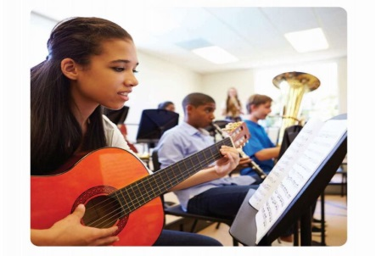

1. geography (n) /dʒiˈɒɡ.rə.fi/ môn Địa lý



1. literature (n)  /ˈlɪt.rə.tʃər/ môn Ngữ văn



1. physics (n) /ˈfɪz.ɪks/ môn Vật lý

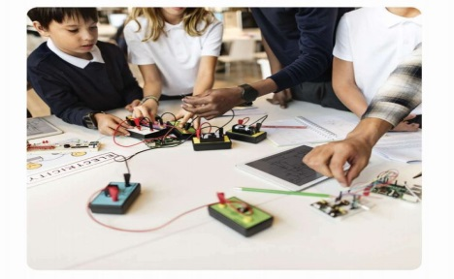

1. biology (n)  /baɪˈɒl.ə.dʒi/ môn Sinh học

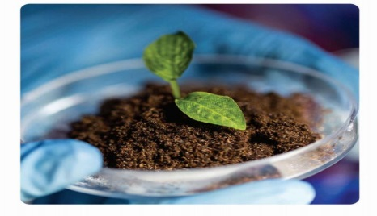

( viết vào tập)

|  |  |
| --- | --- |
| NEW WORDS | MEANINGS |
| 1. history (n) | môn Lịch sử |
| 2. P.E (n) (physical education ) | :môn Thể dục |
| 3. I. T.(n) information technology ) | môn Tin học |
| 4. music (n) | môn Âm nhạc |
| 5. geography (n) | môn Địa lý |
| 6. literature (n) | môn Ngữ văn |
| 7. physics (n) | môn Vật lý |
| 8. biology (n) | môn Sinh học |

***Match each vocabulary item with its English definition or description :*** ( không viết)

1. history a. a school subject about works or poems

from writers or poets.

1. P.E b. a school subject about how to sing songs

(Physical Education ) or play musical instrument.

1. I.T. c. a school subject about features of the

(Information Technology ) areas or places around us such as climate,

weather, or people.

1. music d. a school subject about past events.
2. geography e. a school subject about matters and energy

such as movements, heats, light, and sound

1. literature f. a school subject about living things such

as humans, animals, or plants

1. physics g. a school subject about how to use computers.
2. biology h. a school subject about how to play sports

or do body movements to have good health.

1. **GRAMMAR :** ( viết vào tập)

**1/ Conjunctions : “ and” , “ or”**

1. What subjects do you like ?
2. I like English, physics and literature.
3. What subjects don’t you like ?
4. I don’t like math, biology, or music.
5. What’s your favorite subject ?
6. Mine’s English. What’s yours ?
7. Mine’s art.
8. Oh, I don’t like art.

**Notes** :

* We use “and” to join two or more nouns in a positive sentence. We use “or” to join two or more nouns in a negative sentence.
* We use “mine” or “yours” so we don’t say the same words again.

(e.g : My favorite subject ‘s physics. What’s yours ?

Mine’s English. (your favorite subject)

( My favorite subject)

**2/ Possessive Pronouns ( viết vào tập)**

|  |  |
| --- | --- |
| Possessive Adjective | Possessive Pronouns |
| My | mine |
| your | **yours** |
| His | His |
| Her | Hers |
| Its | Its |
| Our | Ours |
| Their | Theirs |

Examples :

1. This is my car . This car is mine.
2. This is their house. This house is theirs.
3. This is our kitchen. This kitchen is ours.
4. This is his special moment. This special moment is his.

**Notes** :

The Possessive Pronoun stands alone. It replaces the noun . We use it to avoid repeating the same word.

1. **PRONUNCIATION** ( viết vào tập)

Intonation for lists goes up, up, then down.

Ex: I like art , music , and physics

1. **PRACTICE:** ( viết vào tập)

**Exercise 1: What subjects do you like?**

**I like …………………..**

**I don’t like ………………..**

Ex: I like Math and English. I don’t like Physics.

1. She …………………………………………………………..
2. Nam ………………………………………………………..
3. We …………………………………………………………
4. The students ……………………………………………..
5. My sister ………………………………………………..

**Exercise 2** : **Fill out the correct possessive pronouns** :

1. I have a dog. That dog is _________.

2. She has a cat. That cat is _________.

3. We have a car. That car is ________.

4. They have a bike. That bike is ________.

5. He has a key. That key is _________.

6. You have a hat. That hat is _________.