**UNIT 5- LISTEN**

(HỌC SINH TỰ HỌC)

1. **NEW WORDS:**

- report card /rɪˈpɔːt - kɑːd/ (n): phiếu báo kết quả học tập

- excellent /ˈeksələnt/(a): xuất sắc

- behave /bɪˈheɪv/(v): cư xử, đối xử

-  participation /pɑːˌtɪsɪˈpeɪʃn/: sự tham gia

- cooperation /kəʊˌɒpəˈreɪʃn/(n): sự hợp tác

- satisfactory /ˌsætɪsˈfæktəri/(a): thảo mãn, hài lòng

- signature /ˈsɪɡnətʃə(r)/(n): chữ ký

- report /rɪˈpɔːt/(v): thông báo

**2. AUDIO SCRIPT:**

**Miss. Lien:** Good evening, Mr. Lam and Mrs. Linh.

**Mr. Lam:** Thank you.

**Miss Lien:** I’m pleased to tell you that Nga has worked very hard this year and her grades are very good.

**Mrs. Linh:** I'm so pleased to hear that.

**Miss. Lien**: She missed 5 days of school due to sickness but the attendance of 87 days for the whole term is acceptable. Both her participation and cooperation are satisfactory. So, there’re no problems there.

**Mrs. Linh:** How is she doing in English?

**Miss. Lien:** Her speaking and reading are excellent and her writing is good. If she works a bit harder on her writing skills, she should get an A for writing next term.

**Mrs. Linh:** How about comprehension?

**Miss. Lien:** I'm afraid she’s not very good at that. I gave her a C.

**Mrs. Linh:** How can we help her improve?

**Miss. Lien:** Get her to watch English TV if possible, and encourage her to listen to English radio programs. Also, I have some cassettes here which you can borrow.

**Mr. Lam:** Thank you very much, Miss Lien. We really appreciate your help.

**3.LISTEN TO THE DILOGUE AND COMPLETE THE REPORT CARD**

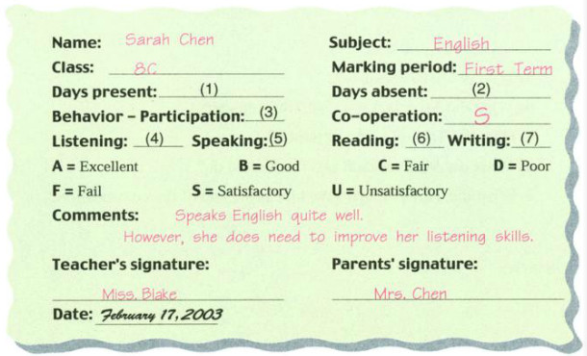

**4. ANSWER KEY**

(1) 87               (5) A

(2) 5                 (6) A

(3) S                 (7) B

(4) C