Unit 4:AT SCHOOL.
I. Choose the word that has the underlined part pronounced and stress syllable differently from the others
1. dictionary right library science ______________
2. word work world womder ______________
3. congress capital cortain cyclist ______________
4. shelf left chemistry open ______________
5. snack area rack calender _____________
6. watch chicken chemistry bench _____________
7. addresses stoves shelves games _____________
8. cafeteria compliment biology dictionary ______________
9. favorite terrible dangerous delightful _____________
10. receive physics science author _____________
II. Choose one of the options to complete these sentences. Write your answers into the blank spaces.
1.What is your____________________subject?
good better popular favorite
2. ____________does Hoa have English class?
What How Where What time
3.School in the USA different ________________ school in Viet Nam.
with at for from
4.These books are on the shelf_______________ the right.
by on to in
5.students usually wear school______________ .
clothes shirts uniform jeans
6.Minh _________________ history and geography on Wednesday.
have has having does
7.Most of students enjoy_________________ books in their free time.
read to read reading to reading
8.There are many science books________________ in the library.
from English with English by English in English
9.students have two ________________ break each day.
twenty-minute twenties-minute twenty-minutes twenties-minutes
10.There are ______________lessons on Saturday and Sunday.
none not no never
11.Classes _____________ 7 a.m and__________________at 4.30 p.m every day.
start-end starts-ends end-start ends-starts
12._____________do you have music?-On Friday.
What Where How When
13.Is Hoa going to the libray? __________________.
She is yes,she is No,she doesn't Yes,She is going
14.students can borrow books from the____________.
bookstores library canteen readers
15.
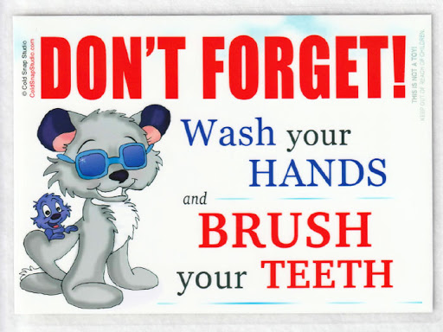 | - - Remember not to wash your hands and clean your teeth.  - - Don't forget to wash your hands and clean your tooth.  - - Remember to wash your hands and wear your glasses.  - - Forget to wash your hands and clean your teeth.

16.
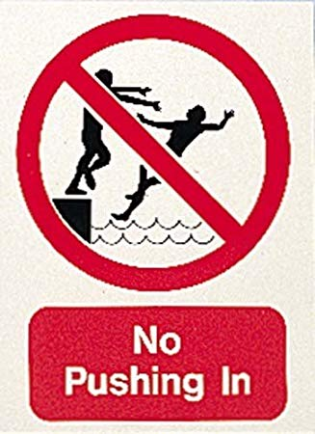 | - Be able to play in the pool.  - Do not push someone in this place.  - Caution! Wet floor.  - Jump into water here.

III. Choose the words in the box to complete the following passage. Write your answers into the blank spaces. (1.5 pts)
also borrow with on in different newspapers have a lot of
My school library is big.All the teachers and students come there to read and(1)_______________ books.Many kind of books for the students from grade 6 to grade 9 are(2)__________the shelf on different sections,such as math,physics,chamistry.biology and English books.There are(3)____________a lot of readers,novels and reference books.On the large and long table(4)___________the middle of the room are many kind of (5)______________and magazines.
IV. Use the correct form of the word given in each sentence. Write your answers into the blank spaces.
1.The city library has over 50__________________. (employ)
2.English is an _________________ and important suject. (interest)
3.science books are very ______________for our study of the world. (use)
4.They have ______________in finding a suitable apartment. (difficult)
5.The most popular after school _______________are football and baseball. (act)
V. Rearrange the groups of words in a correct order to make complete sentences. Write your answers into the blank spaces.
1.the /borrow /books /Students /can / from /library /./
_________________________________________________________________________________________
2.Many /put /of / are /kinds / shelves / books / the / on / .
_________________________________________________________________________________________
3.and /subjects /Math /English /are / favorite .
_________________________________________________________________________________________
4.usually /Wednesday /Friday/and/have/We/on/literature .
_________________________________________________________________________________________
5.school /What / open / time /our /does ?
_________________________________________________________________________________________
6.The girls /eating /breakfast /at the can teen/ are /now/.
VI. Rewrite each of the following sentences in another way so that it means almost the same as the sentence printed before it. Write your answers into the blank spaces.
1. The school library has over five thousand books.
→ There are _______________________________________________ _____________________________
2.I like math than any other subjects?
→ Math is________________________________________________________________________________
3. These racks are on the left.They have magazines.
→ These racks on _________________________________________________________________________
4.There is a big library in Lan'school.
→Lan'school ___________________________________________________________________________
5. She goes to school at six fifteen.
→ She goes to school at_____________________________________ _____________________________
VIII.Answer the questions.
1.What time do you get up?____________________________________________________________________
2.What time do classes start?_______________________________________________________________
3.What ís Lan studying?__________________________________________________________________
4.When do you have English?________________________________________________________________
5.What is your favorite subject?______________________________________________________________
6.Where can you borrow books?_____________________________________________________
7.Where are the books in English?___________________________________________________________
IX.Make question with the underline words or a phrase of words.
1.She studies Math on Monday and Thursday.>___________________________________________________
2.The library opens at 7.30 in the morning.>_____________________________________________________
3.The school library contains over 20 thousand books.>___________________________________________
4.My mother is cooking in the kitchen.>_________________________________________________________
5/The rack of science books are on the left.>_______________________________________________________

-Hết-

