UNIT 1: BACK TO SCHOOL
Part B: NAMES AND ADDRESSES
- Listen. Then practice with a partner.
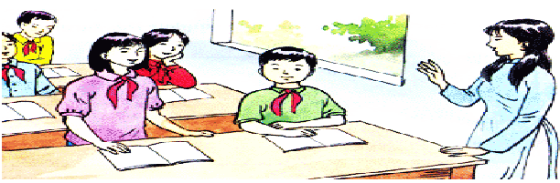

Miss Lien: What's your family name, Hoa?
Hoa: It’s Pham. My middle name's Thi.
Miss Lien: How old are you?
Hoa: I’m 13.
Miss Lien: Where do you live?
Hoa: 12 Tran Hung Dao Street.
Miss Lien: Thank you, Hoa.

New words:
- family name (n)
- middle name (n)
- first name (n)
- full name (n)
- address (n)
- what
- where
- how
Notes:
- What's your family name, Hoa?
It's Phạm.
- Where do you live?
I live in Hue.
on Tran Hung Đạo Street.
at 12 Trần Hưng Đạo Street.

Answer the questions:
a) Who is Hoa talking to?
Hoa is talking to Miss Lien.
b) What is Hoa's family name?
Her family name is Pham.
c) What is her middle name?
Her middle name is Thi.
d) Where does she live?
She lives at 12 Tran Hung Dao Street.
- Write. Complete this dialogue.



Nga: Who is that?
Lan: That's Nam.
Nga: No. Who is the girl talking to Miss Lien?
Lan: Her name's Hoa. She's a new student.
Nga: Which class is she in?
Lan: She is in our class — class 7A.
Nga: Where does she live?
Lan: She lives on Tran Hung Dao Street with her aunt and uncle.
Nga: Where do her parents live?
Lan: They live in Hue.
Nga: She's tall. How old is she?
Lan: She's 13.

- Ask your partner questions and complete this form

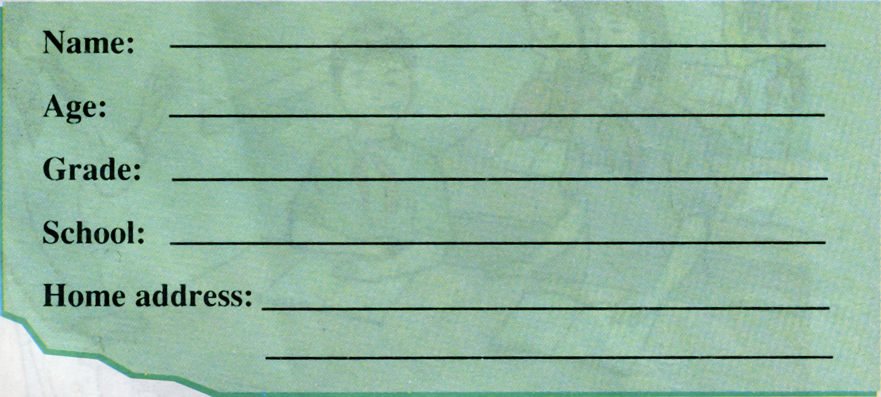

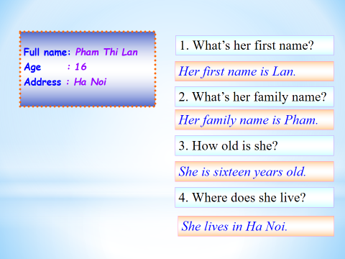

- Listen. Then practice with a partner
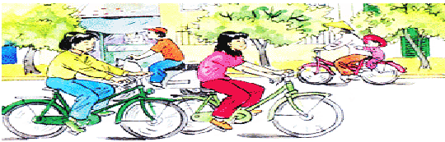

Nam: Where do you live, Hoa?
Hoa: I live at 12 Tran Hung Dao Street.
Nam: How far is it from your house to school?
Hoa: It’s not far - about one kilometer.
Nam: How do you go to school?
Hoa: I go to school by bike

New words:
- market (n)
- movie theater (n)
- post office (n)
- bus stop (n)
- means of transport
- distance (n)
Notes:
- How far is it from your house to school?
It's not far – about one kilometer.
- How do you go to school?
I go to school by bike.
- Ask and answer with a partner


a) How far is it from your house to the market?
=> It's about one kilometer and a half.
b) How far is it from your house to the movie theatre?
=> It's about 3 kilometers.
c) How far is it from your house to the post office?
=> It's about 2 kilometers and a half.
d) How far is it from your house to the bus stop?
=> It's about one kilometer.

- Listen and write:
How far is it? Write the four distances.
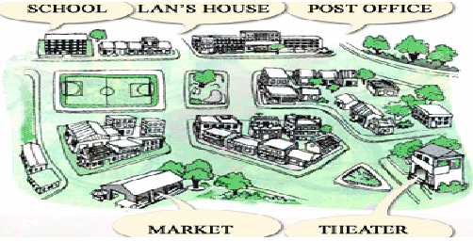

Tapescript:
A. Lan: My English book is still at home.
Hoa: How far is it from school to your house, Lan?
Lan: It’s about 300 meters. I can go home at recess.

B. Hoa: I need some stamps. Where is the post office, Lan?
Lan: It’s not far from my house. Come with me.
Hoa: How far is it from your home?
Lan: Only 700 meters.

C. Lan: Let’s go to the movies.
Hoa: OK. Where is the movie theater?
Lan: It’s in the center of Hanoi.
Hoa: How far is it from school?
Lan: It’s three kilometers. We can take the bus number two.

D. Hoa: Oh! My letter is in my pocket.
Lan: We can post it after the movie.
Hoa: How far is it from the movie theater to the post office?
Lan: About two kilometers.
