I. Choose the word whose underlined part is pronounced differently from that of the other words.
1. A. nice B. invite C. science D. dictionary
2. A. rack B. snack C. happy D. parents
II. Choose the word that has a different stress pattern from that of the other words.
3. A. nervous B. awful C. lovely D. complaint
4. A. delicious B. delightful C. expensive D. horrible
III. Choose the word/ phrase (A, B, C or D) that best fits the space in each sentence.
5. What’s your _____________name – Tran Thi Lan
A. full B. family C. first D. middle
6. I hope you_______________ the exam
A. pass B. will pass C. pass D. is passing
7. February is the _____________month of the year
A. one B. first C. two D. second
8. _______________any toothpaste?
A. Is there B. Are there C. Is that D. Are those
9. Have a nice day! Take care _________________yourself.
A. on B. of C. up D. off
10. I _________________it fun to study English
A. make B. get C. find D. call
11. _____________is it from here to the market?
A. How long B. How far C. How much D. How often
12. Your bike is___________than mine.
A. good B. better C. best D. bad
13. She____________18 on her next birthday.
A. will be B. will is C. is D. be
14. Nam: “I like English.” - Minh: “ Oh,______________.”
A. So do I B. So I am C. So am I D. So will I
IV. Look at the signs. Choose the best answer (A, B, C or D) for each sign.
 | 15. This sign means:  A. Turn left only.  B. You mustn’t turn left  C. You can’t turn right  D. All are correct.
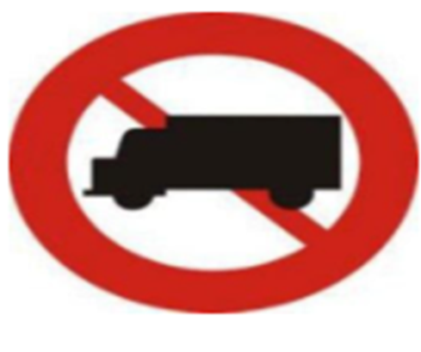 | 16. What does the sign say?  A. Van can move on this road  B. Van is forbidden to move on this road  C. No vehicles please!  D. Van over 20 tons can continue going.
V. Read the following letter. Decide if the statements from 17 to 20 are True or False and choose the correct answer (A, B, C or D) for the questions 21 and 22.
Dear Hoa,
How are you? I’m fine. I’m not busy at the moment. I usually get up at a quarter to six. After I have breakfast, I go to school. I usually go to school at a quarter to seven. I have classes from seven to a quarter past eleven.
At a quarter past twelve, I have lunch. In the afternoon, I do my homework and learn to swim.
In the evening, I watch television. I go to bed at ten to ten.
How do you spend your day?
Write to me soon.
Love,
Yoko
17. Yoko usually gets up at 6.15
A. True B. False
18. She usually goes to school at 6.45.
A. True B. False
19. Her classes starts at 11.15
A. True B. False
20. She goes to bed at 10.10
A. True B. False
21. What time do her classes finish?
A. at eleven fifteen B. at eleven C. at a quarter to eleven D. at seven
22. What does she do in the evening?
A. She listens to music B. She watches TV
C. She goes out with her friends D. She does her homework
VI. Choose the word (A, B, C or D) that best fits the blank space in the following passage. (1.5 pts.)
Hi! My name’s Susan. I live in a house (23)___________ the countryside in the South of France. It’s (24)_______________ old farmhouse, about five hundred years (25) _______________, with very thick walls, so it’s warm in winter and cool in (26)___________. There (27)__________ three bedrooms, two quite big and one small. There is a small garden (28)____________ of the house. and I grow a lot of flowers and vegetables there.
23. A.in B. at C. on D. Ø
24. A. a B. an C. the D. Ø
25. A. old B age C. long D. tall
26. A. summer B. spring C. autumn D. fall
27. A. is B. are C. has D. have
28. A. behind B. next C. near D. in front
VII. Use the correct form of the word given in each sentence.
29. The city library has over 60_____________. (employ)
A. employ B. employs C. employees D. employee
30. English is an ____________and important subject . (interest)
A. interest B. interested C. interesting D. interests
31. Science books are very ___________for our study of the world (use)
A. used B. useful C. using D. uses
32. The most popular after-school _______________ in Vietnam are football, badminton, and basketball. (act)
A. activity B. activities C. acts D. acting
33. You can find many kinds of books: ____________, novels, ad dictionaries. (read)
A. reader B. reads C. readers D. reading
34. What a ____________bedroom? (love)
A. loves B. love C. lovely D. loving
VIII. Rearrange the groups of words in a correct order to make complete sentences.
35. the white/is/ washing machine/ than/ bigger/ than/ the green one/./
A. The white washing machine is bigger than the green one
B. The green one bigger is than the white washing machine
C. The white washing machine is than bigger the green one
D. The white washing machine is the green one bigger than
36. most/ apartment/ family/ is/ the/ your/ suitable/ which/ for/?/
A. Which the most apartment is suitable for your family?
B. Which is the most suitable apartment for your family?
C. Which family is the most suitable for your apartment?
D. Which the most is suitable apartment for your family?
IX. Choose the sentence (A, B, C or D) that best fits for each of the following sentences in another way so that it means almost the same as the sentence printed before it.
37. The weather is very nice
A. What a nice weather!
B. What nice weather!
C. What weather nice!
D. What is weather nice
38. When’s her birthday?
A. What’s her date of birth?
B. When’s her date of birth?
C. What’s her birthday?
D. When’s her birth of date?
39. Let’s go by bus.
A. What about go by bus?
B. What about to go by bus?
C. What about going by bus?
D. What about goes by bus?
40. We have Geography class at six twenty
A. We have Geography class at twenty to six
B. We have Geography class at twenty past six
C. We have Geography class at five fifty
D. We have English class at fifty to five.

------THE END------

