Tuần 5 từ 4/10 đến 9/10/21

SPEAK ( Hs tự học)

# LISTEN UNIT 3 p.[30 SGK Tiếng Anh 8](https://loigiaihay.com/listen-unit-3-trang-30-sgk-tieng-anh-8-c75a18726.html)

* New word :

|  |  |
| --- | --- |
| 1. dish rack (n) : …………………………  2. beneath : ……………………………  3. cutting board (n) : ……………………  4. flower vase (n) ………………………  5. big pan (n) : ……………………………  6. pot : …………………………………  7. ham (n) : ……………………………  8. pea (n) : ………………………………  9. bowl (n) : ……………………………  10. rug (n) : ……………………………  11. calendar (n) : …………………………  12. counter (n) : …………………………  13. saucepan : …………………………  14. garlic (n) : …………………………  15. decide – decided (v) : ……………… | UNIT 3 : AT HOME  \**Tape transcript:*  Lan: Can I help you cook dinner, Mom?  MrsTu: Sure. You can cook the *“Special Fried Rice”* for me.Use the big pan, please.  Lan: Okay. How much oil do I put in?  MrsTu: Just a little. Wait until it’s hot and then fry the garlic and the green peppers.  Lan: Do I put the ham and the peas in now?  MrsTu: Yes. And you can put the rice and ate a teaspoon of salt in.  Lan: Yummy! It smells delicious. |

**Look at the pictures. Check the right item**

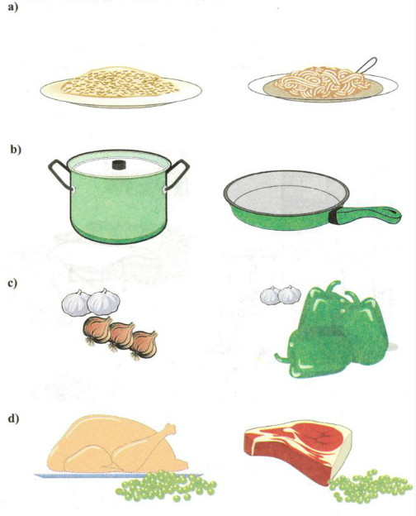

# 

# READ UNIT 3 : [31 SGK Tiếng Anh 8](https://loigiaihay.com/read-unit-3-trang-31-sgk-tieng-anh-8-c75a18727.html)

* New word :

|  |  |
| --- | --- |
| 1. Safe (a) – safely (adv) – safety (n): ……………… 2. Precaution (n) : ……………………………… 3. Community(n) Communal : …………………… 4. Chemical (n): ……………………………… 5. Drug (n) : ………………………………………… 6. Soft (a) : …………………………………………   Soft drink : …………………………………………   1. Lock (v) – locked (a): ………………………………   ______ cupboard : ( clock): ……………………   1. Match (n) : ………………………………………… 2. Detroy (v) – destruction (n) – destructive (a): ……. 3. Injust (v) : ……………………………… 4. cause a fire (v): ……………………………… 5. cover (v): ………………………………………… 6. Electrify (v) – Electricity(n)- Electrician(n) : thôï ñieän – Electrical(a) : ………………………………   Electrical socket : ………………………………   1. object (n): Many household object: ………… 2. include : ………………………………………… 3. bead : ………………………………………… 4. out of children’s reach : …………………… 5. suit (n) – suitable (a) suitably(adv): …………… | Notes :   1. Locked cupboard : 2. You mustn’t ______ children ______ in the kitchen.( let/ play ) 3. You have ___________ all dangerous objects ____ of children ‘s reach. ( keep / gtu ) 4. It takes one match _______________ a fire . (cause) 5. The kitchen is a ______________ place. (danger) 6. You must cover ______________ sockets. (electricity) 7. _________________ can kill. ( electric) 8. A kitchen isn’t a ____________ place to play. (suit ) |

**READ.**

Lan’s mother, Mrs. Quyen, is at her local community center. She is reading one of the posters on the wall.

**Safety Precautions in the Home**

- You must put all chemicals and drugs in locked cupboards. Children may drink or eat these things because they look like soft drinks or candy.

- You must not let children play in the kitchen. The kitchen is a dangerous place.

- You have to make sure children do not play with matches. Each year, fire destroys homes and injures children because someone plays with matches. Remember, it only takes one match to cause a fire.

- You must cover electrical sockets so that children do not try to put anything into them. Electricity can kill.

- You have to keep all dangerous objects out of children's reach. These include scissors, knives, and small objects such as beads.

**Task 1. Answer**

**True or false? Check (✓) the boxes. Correct the false sentences.**

|  |  |  |
| --- | --- | --- |
|  | **T** | **F** |
| a) It is safe to leave medicine around the house. |  |  |
| b) Drugs can look like candy. |  |  |
| c) A kitchen is a suitable place to play. |  |  |
| d) Playing with one match cannot start a fire. |  |  |
| e) Putting a knife into an electrical socket is dangerous. |  |  |
| f) Young children do not understand that many household objects are dangerous |  |  |

**Task 2. Ask and answer.**

a) Why must we put all chemicals and drugs in locked cupboards?

Because children often try to eat and drink them.

b)   Why mustn’t we let children play in the kitchen?

Because ____________________ .

c)    Why mustn’t children play with matches?

Because ____________________ .

d)   Why must we cover electrical sockets?

Because ____________________ .

e)   Why do we have to put all dangerous objects out of children’s reach?

Because ____________________ .

Homework

1. Các em chép bài vào tập bài học.

2 . Dịch Listen, read

3. Copy từ vựng lần vào tập

4.Hạn chót nộp chụp bài lên group là lúc 17h00 thứ 6 nhé.

5. Chuẩn bị write Ex1,2 trong SGK P.32, 33, Language focus Ex1,3 Unit 3 trong SGK P. 34, 35, listen and read : gạch dưới từ vựng mới, dịch trước bài đọc và làm Ex2, 3 trong SGK trang 39

Chúc các em làm bài thành công và ôn tập, củng cố kiến thức mới thật tốt.

Bài tập vận dụng : (Unit 3)

**Chia động từ trong ngoặc**

1. My father (jog) ............................................ every morning.

2. We (visit) ................................... Hương Pagoda next week.

3. She (be) ........................................ 14 on her next birthday.

4. They (live) ................................... with their grandparents.

5. He (have) .......................................... a lot of friends soon.

6. Mai (brush) ...........................................her teeth after meals.

7. I (come) ...................................................... back tomorrow.

8. She (have) ............................................... a meeting tonight.

9. Lan (invite) some of her friends to her birthday party on Sunday.

10. Hoa (go) ........................................... swimming every day.

11. We often ............................. (play) tennis in the afternoon.

**Viết lại câu.**

1, You shouldn’t stay up late to watch TV.

You………………………………………………………………..

2, We finds it interesting to work together.

It’s……………………………………………………………………………….

3, No one helps me to do the housework every day.

I……………………………………………………………………

4, Do you have to go out right now?

Must………………………………………………………………

5, The microwave is behind the refrigerator.

The refrigerator is……………………………………………….

6, Doing morning exercise is very good for your health.

It’s……………………………………………………………….

7, It’s dangerous to swim in this river without adults.

Swimming………………………………………………………….

8, It’s not easy to do the English exercises alone.

Doing………………………………………………………………

9, Walking to school every day is good for our health and environment.

It’s ……………………………………………………………………….

10, It isn’t necessary for you to go shopping in the cold weather like this.

Going……………………………………………………………………….

11, Learning foreign languages is very helpful for us in the future.

It’s………………………………………………………………………….