UBND QUẬN BÌNH THẠNH
TRƯỜNG TRUNG HỌC CƠ SỞ
LAM SƠN
NỘI DUNG HƯỚNG DẪN HỌC SINH TỰ HỌC
Môn Tiếng Anh - Khối lớp: 8
Tuần 5 học từ ngày 4/10 đến ngày 9/10/2021
UNIT 3: AT HOME
PERIOD 1: LISTEN

- VOCABULARY:

 | Special Chinese fried rice | / ˈspeʃl ˌtʃaɪˈniːz fraɪd raɪs/ | n | Cơm chiên Dương châu
2 | Pan | / pæn / | n | Cái chảo
3 | Ham | / hæm / | n | Thịt heo

- PRACTICE

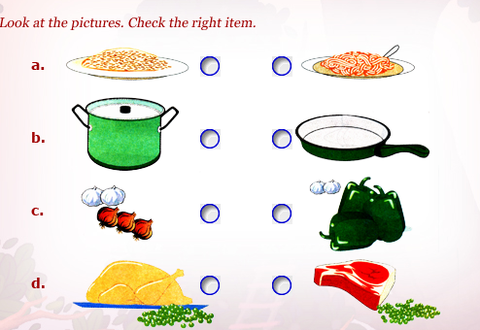

PERIOD 2: READ

- VOCABULARY:
Precaution | /prɪˈkɔːʃn/ | (n) | sự phòng ngừa, sự đề phòng
Safety | /ˈseɪfti/ | (n) | sự an toàn
→ safe | /seɪf/ | (adj) | an toàn
→ safely | /ˈseɪfli/ | (adv) | một cách an toàn
Chemical | /ˈkemɪkl/ | (n) | hóa chất
Drug | /drʌɡ/ | (n) | thuốc
Match | /mætʃ/ | (n) | diêm
Injure | /ˈɪndʒə(r)/ | (v) | làm bị thương
Socket | /ˈsɒkɪt/ | (n) | ổ cắm điện
Scissors | /ˈsɪzəz/ | (n) | cái kéo
Bead | /biːd/ | (n) | hạt, vật tròn nhỏ
Cause a fire | /kɔːz ə ˈfaɪə(r)/ |  | gây ra hỏa hoạn

- GRAMMAR:
Cấu trúc câu hỏi – trả lời: Why? – Because
- Why là trạng từ để hỏi (interrogative adverb) hay còn gọi là từ để hỏi (question word), được dùng để hỏi về lí do. Why có nghĩa là tại sao, vì sao, vì lí do gì, với mục đích gì.
- Because là liên từ (conjunction) có nghĩa là “vì, bởi vì”, được dùng để trả lời cho câu hỏi về lí do bắt đầu bằng Why.
- Example: 1. Why are you late all the time? → Because I often stay up late.
2. Why do you buy these shoes? → Because I like them.
- PRACTICE
Exercise 1: Read the passage and then decide the statements followed are TRUE or FALSE. Then correct the false sentences.
a. It is safe to leave medicine around the house.
b. Drugs can look like candy.
c. A kitchen is a suitable place to play.
d. Playing with one match cannot start a fire.
e. Putting a knife into an electrical socket is dangerous.
f. Young children do not understand that many household objects are dangerous.

Exercise 2: Read the passage again and answer the following questions
a. Why must we put all chemicals and drugs in locked cupboards?
→ Because children often try to eat and drink them.
b. Why mustn’t we let children play in the kitchen?
→…………………………………………………………………………………………
c. Why mustn’t children play with matches?
→…………………………………………………………………………………………
d. Why must we cover electrical sockets?
→…………………………………………………………………………………………
e. Why do we have to put all dangerous objects out of children’s reach?
→…………………………………………………………………………………………

Exercise 3: Multiple choice
1. It ……. important to be aware of safety precautions in the home.
A. was B. are C. is D. isn’t
2. You ……. put chemicals and drugs in locked cupboards.
A. mustn’t B. must C. shouldn’t D. haven’t to
3. A kitchen is a ……. place to play.
A. safe B. suitable C. exciting D. dangerous
4. We mustn’t let children ……. with matches.
A. plays B. play C. to play D. playing
5. ……. must we cover electrical sockets? - Because children can put something in them.
A. What B. When C. Why D. Where
6. Choose the word that has underlined part pronounced differently.
A. sink B. knife C. fire D. rice
7. Choose the word that has underlined part pronounced differently.
A. house B. couch C. ought D. counter

Exercise 4: Fill in the blanks by using the give words
mustn’t locked one cover matches keep

1. You must put all chemicals and drugs in ________ cupboards.
2. You _______ let children play in the kitchen
3. You have to make sure children do not play with _______.
4. It only takes _______match to cause a fire.
5. You must ________ electrical sockets so that children do not try to put anything into them.
6. You have to _______ all dangerous objects out of children’s reach.

- HOMEWORK
- Learn the VOCABULARY by heart.
- Prepare the next Lesson
*Các em chép phần chữ màu đỏ vào tập phần còn lại chép đáp án.

