Unit 12: A Vacation Abroad
Section : Read
Read these postcards from Mrs. Quyen to her children.
- Vocabulary :
1. carve | v. | chạm khắc
2. gallery | n. | phòng trưng bày
3. lava | n. | dung nham
4. overhead | adv. | phía trên đầu
5. prison | n. | nhà tù
6. situate | v. | đặt ở vị trí
7. souvenir | n. | đồ lưu niệm
8. valley | n. | thung lũng
9. wharf | n. | cầu tàu
10. Volcano | N | Núi lửa
11. Pour – out | V | Tuôn trào

1. Write what Mrs. Quyen did and saw in each of these places.

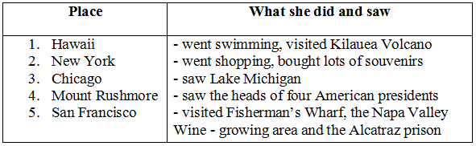
2. Answer the following questions.
a) How did Mrs. Quyen go to Kilauea Volcano?
=> She went there by plane.
b) Where in San Francisco did Mrs. Quyen see the famous prison?
=> She saw the prison on the island of Alcatraz.
c) What is special about Mount Rushmore?
=> People can see Mount Rushmore from more than 100 kilometres away.
d) What is the other name of Chicago?
=> It is also called "The Windy City".
e) What did Mrs. Quyen do while her husband was visiting the Statue of Liberty?
=> She went shopping.

