**THEME 5: Around Town - Grade 6**

**PHIẾU HỌC TẬP**

**Week 16 - P: 31,32**

**Date: 20/12 – 25/12**

**LESSON 3**

1. **NEW WORDS.**
2. **Read the clues and do the crossword puzzle**

|  |  |
| --- | --- |
| 1. Cook food over fire. 2. Food from the sea like fish and sauce. 3. Plants used to make food taste nicer. 4. Meat from a pig. 5. Cook food in oil. 6. Meat from a sheep. 7. People eat this brown or orange liquid with rice or noodles. 8. Meat from a cow. 9. A type of long and thin shaped food. |  |

1. **Fill in the blanks using the words in task A.**
2. Steak-fries is a kind of meat dish. It’s _______________ and french fries.
3. We________ the sausages on the barbecue.
4. You can get food __________ in this restaurant. They serve really good crab and shrimp.
5. I don’t like to eat grilled beef or pork, so I had grilled __________.
6. _____________ the steak in a little butter. It’s so good.
7. Pad see ew is a popular dish from Thailand with fried ___________.
8. I really like fried ___________. Bacon is my favorite type.
9. I like to put chili in my _______ and pour it on my noodles.
10. My mom uses_______ from the garden to make our food taste amazing.
11. **READING.**
12. **Read the article and write the names of the dishes next to the pictures:**

**FOOD IN VIET NAM**

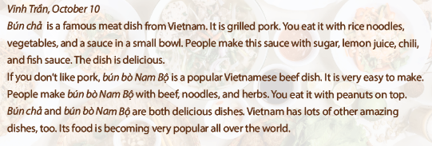

1. 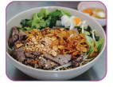_____________________________.
2. 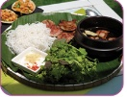 ______________________________.
3. **Read the article again and write the answers.**
4. What meat is in bún chả?

* The meat is grilled pork.

1. What do you eat ***bún chả*** with?

* ___________________________________________________________________________________.

1. What do they make the sauce in ***bún chả*** with?

* ___________________________________________________________________________________.

1. What do people make b***ún bò Nam Bộ*** with?

* ______________________________________________________________________________________.

1. What do you put on top of ***bún bò Nam Bộ*** ?

* _________________________________________________________________________________________.

**C. WORD FORMATION**

***Write the correct forms of the words in the brackets.***

1. My favorite dish is _______________ rice with eggs. It’s very delicious. (**FRY**)

2. Paul works as a sales _______________ in a department store. (**ASSISTANCE**)

3. Excuse me, where is the _______________ room? (**CHANGE)**

4. Vietnam has a lot of _______________ dishes, such as *Phở* or *Bún chả*. (**AMAZE**)

5. *Cơm tấm* is a rice dish with _______________ pork. (**GRILL**)

6. These snacks are full of sugar and salt. They are not _______________. (**HEALTH**)