**TIENG ANH 9 ( WEEK : 1 –6/2/2021)**

**Period 1 : Unit 7 : Getting started + Listen and read ( page 57)**

**New words**

1. **be worried about : lo lắng về**
2. **enormous (a) = expensive**
3. **give advice on something (v) cho lời khuyên về việc gì.**
4. **reduce the amount of something (v) giảm lượng--**
5. **get someone to do something = ask someone to do something : nhờ ai làm gì.**
6. **plumber (n) thợ sửa ống nước.**
7. **crack (n) vết nức**
8. **pipe (n) ống nước.**
9. **dripping faucet(n) ống nước bị rỉ giọt**
10. **drip (v)**

**Grammar note:**

**S + suggest doing something = shall we V----? = Let’s V = What/ How about = Ving?**

**Task 2: True or False? Check (√) the boxes. Then correct the false statements.**

(Đúng hay sai. Điền dấu (**√**) vào ô. Sau đó sửa câu sai.)

**Lời giải**

|  |  |  |
| --- | --- | --- |
|  | **T** | **F** |
| 1. Mrs. Ha is worried about her water bill. | **√** |  |
| 2. Mrs. Mi gives Mrs. Ha advice on how to save water. | **√** |  |
| 3. Mrs. Ha has checked the pipes in her house and found no cracks. |  | **√** |
| 4. Mrs. Ha suggests getting some tool to check cracks in the pipes. |  | **√** |
| 5. Mrs. Mi suggests taking showers to save water. | **√** |  |

**Period 2**: **Unit 7 : Listen and Read ( page 58 – 59)**

**Speak** (Trang 58-59 SGK Tiếng Anh 9)

*a) Look at the expressions in the tables and pictures. Make suggestions about how to save energy.*

**A.** I think we should turn off the faucet. I suggest fixing the faucet.

**B.** I suggest turn off the electric oven/ cooker. I suggest repairing the cooker. It may be broken.

**C.** Why don't we switch off the fan? Shall we have an electrician mend the fan?

**D.** I think we should turn off the air conditioner.

**E.** Let's switch off the lights and the TV.

**F.** I suggest fixing the faucet in the bathroom.

**G.** I think we should use bikes instead of motorbikes.

**H.** Why don't we use the public buses?

*b) Work in a group of four. Work out an action plan to save energy for ... .* **Gợi ý:**

**E:** I think we should use energy-saving light bulbs for ordinary bulbs.

**F:** That's a good idea.

**G:** How about turning off the lights and other electric tools when we don't use them?

**H:** OK. Let's do it.

**4. Listen** (Trang 60 SGK Tiếng Anh 9)

**New words**

solar energy (n)

nuclear power (n) năng lượng hạt nhân

power = energy

effective (a) hiệu quả

cause pollution (v)

solar panel (n) pin mặt trời

put (v) = install (v) place

store (v)

on cloudy days : vào những ngày có mây

*a. Listen to the news on solar energy and decide whether the statements ... .*

**Gợi ý:**

**1.** **(T)**

**2.** **(F)**

=> Most of our electricity now comes from the use of coal, and gas, oil or nuclear power.

**3.** **(F)**

=> One percent of the solar energy that reaches the earth is enough to provide power for the total population.

**4.** **(T)**

**5.** **(F)**

=> All buidings in Sweden will be heated by solar energy by the year 2015.

*b. Listen again and fill in each blank with one word you hear.*

**1.** The sun can be an **effective** source of power.

**2.** Solar energy doesn't cause **pollution.**

**3.** A lot of **countries** in the world are already using solar energy.

**4.** It is possible to **store** solar energy for a number of days.

**5.** Solar panels are installed on the **roof** of a house to receive the energy from the sun.

**6.** We can save natural resources by using solar energy **instead** of coal, gas, and oil.

**Nội dung bài nghe:**

Are you looking for a cheap, clean, effective source of power that doesn’t cause pollution or waste natural resources? Look no further than solar energy from our sun. At present, most of our electricity comes from the use of coal, and gas, oil or nuclear power. This power could be provided by the sun. One percent of the solar energy that reaches the Earth is enough to provide power for the total population.

Many countries are already using solar energy. Solar panels are placed on the roof of a house and the Sun’s energy is used to heat water. The energy can be stored for a number of days, so on cloudy days you can use solar energy too.

Sweden has an advanced solar energy program. There, all buildings will be heated by solar energy and cars will use solar power instead of gas by the year 2015.

**Period 2: Unit 10 : B4; B5**

**4. Ask and answer questions with a partner.**

**Use the words to help you.**

*(Hỏi và đáp với bạn cùng học. Dùng từ để giúp em)*

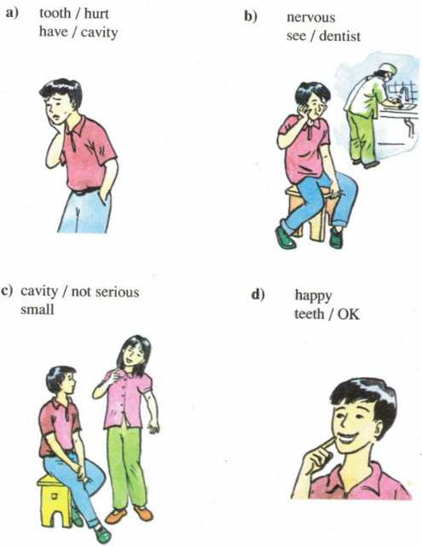

**Hướng dẫn**

a) Minh's tooth hurts.

Why?

Because he has a cavity.

b) He looks nervous?

Why?

Because he is seeing a dentist.

c) The cavity isn't serious.

Why?

Because it’s very small.

d) Minh looks happy.

Why?

Because his teeth are ok now.

**B5.**

**5. Write. Complete this poster with a partner.**

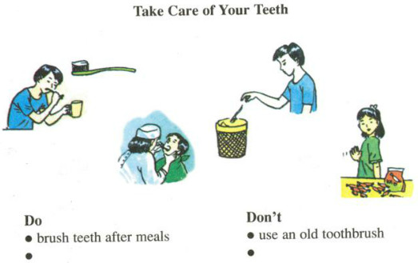

|  |  |
| --- | --- |
| **Take care of your teeth** | |
| **Do** | **Don’t** |
| - Brush teeth after meals  - Use a good toothbrush  - Use good toothpaste  - Go to a dentist when having a toothache | - Use an old toothbrush  - Eat lots of candy and sweets |

**Period 3 : Unit 11 A1**

**A. A check-up** (Phần 1-3 trang 107-109 SGK Tiếng Anh 7)

**1. Listen. Then practice with a partner.**

**New words :**

**have a medical check up (v)**

**fill in the medical record(v)**

**take someone’s temperature (v) đo nhiệt độ**

**degree Celsius ( độ c)**

**normal (a)**

**measure (v)**

**high (a) 🡪 height (n)**

**get on the scale (v)**

**weigh(v) 🡪 weight(n)**