UNIT 4 FESTIVALS AND FREE TIME

– Period 40,41,42
Exercises
Exercise 1: Use the given words to label the picture.
watch fireworks |  | decorate a house or tree |  | watch parades
eat traditional foods |  | get lucky money |  | watch Korean wrestling
visit family and friends |  | play video games |  | buy fruits or flowers
 |  |  | 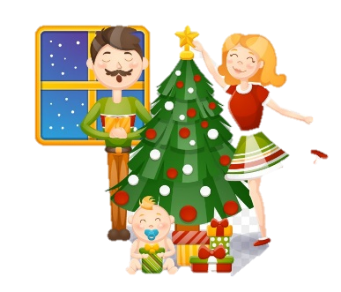 |  | 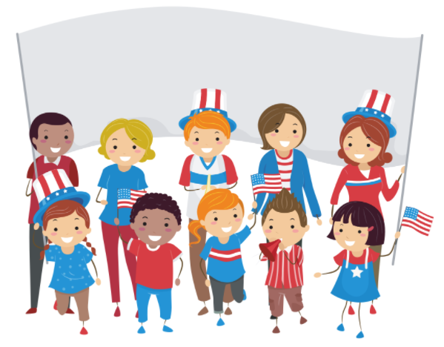
 | - ………………… |  | - ……………… |  | - …………………….
 | 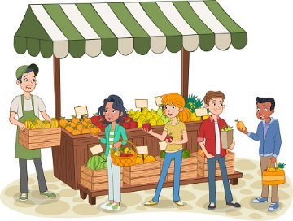 |  | 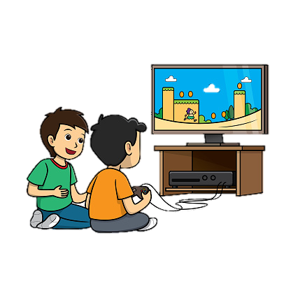 |  | 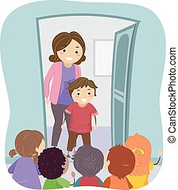
 | 4. ………………………… |  | 5. ………………………… |  | 6. …………………………
 | 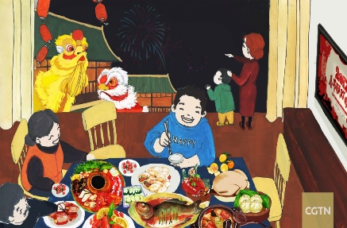 |  | 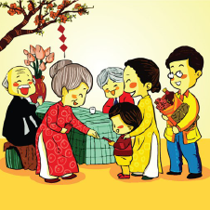 |  | 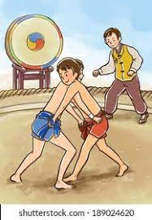
 | 7. ………………………… |  | 8. ………………………… |  | 9.…………………………
Exercise 2. Fill in the blanks using the words in the box.
free on | food stands |  | Lucky money |  | decorating |  | visiting relatives
music performance |  | talent |  | often |  | traditional |  | ends
- They are _______________ the room with flowers and balloons.
- I like Tet because I receive lots of _____________ from my parents and relatives.
- I _______________ play badminton with my dad on the weekends.
- She wants to go to some …………………..because she is hungry.
- The puppet show _______________ in ten minutes.
- _______________ is one of the traditional custom of Vietnam on Lunar New Year.
- I think I'm _______________ that day-let me check my calendar.
- My mother always cooks _______________ food at Tet.
- Thousands of people jammed into People’s Square to watch the _______________ .
- She wants to join the _____________ show because she can sing very well.
Exercise 3: Give the correct form of the verbs in brackets.
1. We ________ (have) an English lesson on Monday. We_________ (not have) on Thursday.
2. Long ___________ (want) to go to the cinema on Sunday.
3. John __________ (be) a student. His brothers ___________ (be) workers.
4. Tomorrow _________ (be) Sunday. We __________ (go) to Cuc Phuong National Park.
5. Mary often ___________ (help) her mother with the housework?
6. They ___________ (not work) at the factory now.
7. How ___________ (do) your father ___________ (go) to work every day?
8. Your parents ___________ (watch) TV in the evening?
Exercise 4: Choose the best answer.
1. My brother ___________ to buy a new car.
A. want B. wanting C. to want D. wants
2. Some Canadians ___________ English and French.
A. speak B. speaks C. to speak D. speaking
3. Tuesday ___________ a very long day for me.
A. is B. are C. to be D. be
4. The teacher ____________ French and English.
A. knowing B. to know C. knows D. know
5. Greek and Chinese ____________ difficult languages to learn.
A. is B. are C. be D. to be
6. A trip from here to London __________ about 7 hours.
A. take B. takes C. taking D. to take
7. Tomorrow’s homework ___________ on page 37.
A. begin B. begins C. began D. beginning
8. Jenny __________ the dishes every day. She hates it.
A. washing B. washes C. to wash D. wash
9. Tam _________ to the cinema every Sunday but her sister doesn’t.
A. go B. to go C. goes D. going
10. All of the teachers in my school __________ young and nice.
A. is B. be C. are D. to be
- Chung cake is a ________ dish of Vietnamese people on Tet holiday
A. luxury B. modernize C. traditional D. delicious
- Peter ________ his room before the 12th birthday party.
A. visit B. rearrange C. paint D. decorated
- Trinh invites Loan to ________.
A. eat dinner with her family B. reads at her home
C. played chess D. go the restaurant
- Lan’s family usually ________ TV in the evening.
A. watched B. watch C. watches D. watchs
- Vietnamese people usually return to their families _________ Tet.
A. in B. on C. for D. during
- When the clock strikes midnight, colorful fireworks light _________ the sky.
A. in B. up C. on D. over
- Tet is the biggest and most important_________ in Vietnam.
A. festival B. decoration C. occasion D. tradition
- I always _________ my grandparents a long life and good health.
A. celebrate B. wish C. make D. bring
- ‘_________ do Vietnamese people prepare for Tet?’ ‘They decorate their houses and cook special food.’
A. What B. Where C. How D. How often
- ‘In which country do people throw water at one another?’‘_________’
A. Scotland B. Thailand C. The USA D. Denmark
- ___________ is the first person to enter your home after New Year’s Eve.
A. The dead B. The rooster C. The fairy D. The first footer
- I’m going to introduce some __________ wonders of the world to you.
A. Nature B. natural C. naturally D. nation
- I finished packing for our picnics. All my things are in my __________
A. Walking boots B. sleeping bag C. backpack D. pencil case
- The________took place in a crowded atmosphere in a southern Australian city
A. party B. parade C. colorful D. demo
- We ____________ go out after eight. My dad doesn't think it's safe.
A. often B. sometimes C. never D. always
Exercise 5: Read the following passage and choose the best answer.
Halloween is a holiday. It is on the night of October 31st . It is_________(1) in many English Speaking countries. Children wear costumes. They go to people’s homes. The people give them _________(2). Children say “trick or treat” to ask for candy. This comes from a theat. It means, “Give me a treat _________(3) I will play a trick on you” Children today _________(4) not do the tricks if they don’t get treats. But some children still do mischief playful pranks or things to make fun of people like putting toilet paper in trees or writing _________(5) soap on windows .In these countries Halloween is about ghosts, witches, goblins, and other scary things.
1. A. presented B. proposed C. celebrated D. played
2. A. candy B. cake C. meat D. egg
3. A . and B. but C. or D. because
4. A . never B. sometimes C. just D. usually
5. A . for B. with C. often D. on to
Exercise 6: Rearrange the words to complete the sentences.
- decorate/plants and flowers/ their home with /./ People /
=> ………………………………………………………………………………………
- /on New Year’s Day/./because /they want good luck/ try to be nice to each other/ People
=> ………………………………………………………………………………………
- , and they exchange /They visit / New Year’s wishes/. /their relatives
=> ………………………………………………………………………………………
- on the weekends./play badminton/with my dad/I/often
=> ………………………………………………………………………………………
- to read books/We/the library/and study./often/go to
=> ………………………………………………………………………………………
- always/goes to/My mom/the supermarket/after work.
=> ………………………………………………………………………………………
- go to the pagoda /a happy year for their family/Many people / in order to have/./
=> ………………………………………………………………………………………
- buy/at the bookstore./new books/My parents/ usually
=> ………………………………………………………………………………………
- never/after school./does/My sister/martial arts
=> ………………………………………………………………………………………
- a time for fun /the country /Tet is / and festivals throughout/./
=> ………………………………………………………………………………………

