NỘI DUNG HỌC TẬP TUẦN 16

MÔN: TIẾNG ANH KHỐI: 7

UNIT 8 – PLACES - B. AT THE POST OFFICE

I. New words

Envelop (n) /in'veləp/ *phong bì*

Altogether (adv) /ɔ:ltə'geðər/ *tổng cộng*

Change (n) /t∫eindʒ/ *tiền thừa*

Local (a) /'ləʊkl/ *địa phương*

Overseas (a) /,əʊvə'si:z/ *ở nước ngoài*

Pen pal (n) /pen pæl/ *bạn qua thư*

Regular (a) /'regjulə/ *đều đặn*

🡪 regularly (adv) /'regjʊləli/

Postcard (n) /'pəʊstkɑ:d/ *bưu thiếp*

Writing pad (n) /'raitiŋ pæd/ *tập giấy viết thư*

Phone card (n) /fəʊn kɑ:d/ *thẻ điện thoại*

Price (n) /prais/ *giá cả*

= cost (n)(v)

II. Structures

* How much *(bao nhiêu)*

How much + $\frac{is/are + S }{do/does +S +cost}$?

= What is the price of + Noun ?

*How much is the cake?*

*🡪 The cake is 5,000 dong.*

*How much does the cake cost?*

*🡪 The cake costs 5,000 dong.*

*What is the price of the cake?*

*🡪 The price of the cake is 5,000 dong.*

*How much are two cakes?*

*🡪 Two cakes are 10,000 dong.*

*How much do two cakes cost?*

*🡪 Two cakes cost 10,000 dong.*

*What is the price of two cakes?*

*🡪 The price of two cakes is 10,000 dong.*

🖊 Write all the new words, meanings, structures and examples in your notebook

*(Viết toàn bộ từ vựng, nghĩa, cấu trúc và ví dụ vào trong tập)*

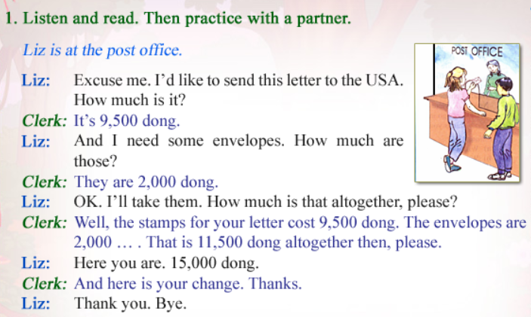

Answer these questions.

1. Where will Liz mail her letter?

🡪 ……………………………………………………………………………

2. How much does Liz pay altogether?

🡪 ……………………………………………………………………………

3. How much change does she receive?

🡪 ……………………………………………………………………………

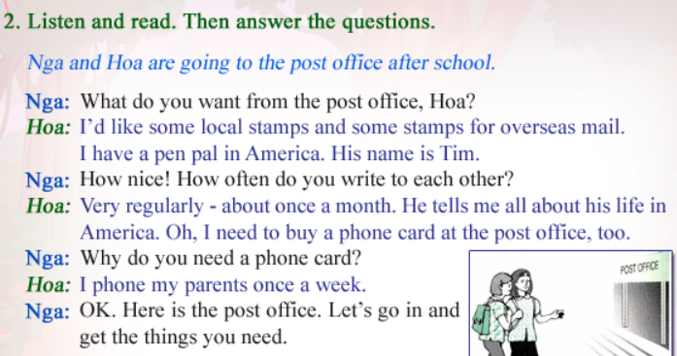

True/False

1. Nga wants to buy something at the post office __________

2. Hoa regularly writes her American friend a letter __________

3. Hoa also needs to buy a phone card __________

Answer the questions

1. What does Hoa need from the post office?

🡪 ……………………………………………………………………………

2. Why does she need stamps for overseas mail?

🡪 ……………………………………………………………………………

3. Why does she need a phone card?

🡪 ……………………………………………………………………………

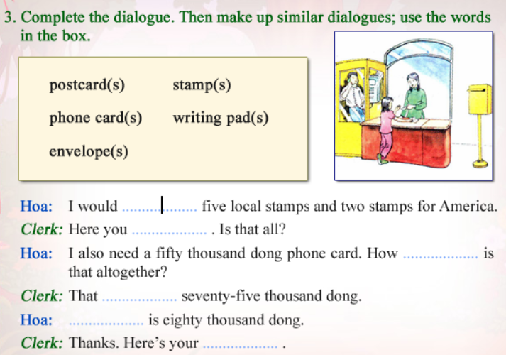

Fill in the blanks to complete the dialogue

Then replace with the words in the box to make a similar dialogue. Remember to change the suitable price.

