**NỘI DUNG HỌC TUẦN 10 - LỚP 8**

**TIẾT 1: HỌC SINH TỰ HỌC VÀ SOẠN BÀI TRƯỚC THEO KẾ HOẠCH TRONG TUẦN**

**Unit 5: STUDY HABITS**

(Period 4: Write)

* **Writing an informal letter**

* **Heading** - writer’s address and the date.
* **Opening** - Dear …,
* **Body of the letter: y**ou have to adjust the language and the wordings according to who you are writing to.
* **Closing** - Say a meaningful and affectionate goodbye to the reader.

- Signature: Your friend/ Regards/ Love, Lots of Love, Best, Best Wishes, Kind Regards

**\* Practice**

1. **Read the following passage and choose the item (A, B, C, or D) that best answers each of the questions about it:**

Dear Maria,

At last! Hooray! We finished all our exams yesterday. The last one was History. It was horrible. I think History is really difficult because I can't remember all the facts and the dates.

I did seven subjects. The worst were Science and History. I found them very difficult. I always forget most of the things we've learned.

The best subject this year was Geography, but we only had it twice a week. We're going to Wales in the middle of August, to see my granddad. Would you like to come with us? Mum says it's OK. Please write and tell me about your year at school. What was it like? Were your exams easy?

Bye for now.

Peter

1. This is a letter to _______.

A. a brother B. a sister C. a friend D. granddad

2. How many subjects did Peter take exams?

A. Two B. three C. four D. seven

3. Peter was good at _______.

A. History B. Science C. Geography D. Math

4. What does the word 'forget' in line 6 mean?

A. not remember B. not know C. not understand D. not like

5. Peter wanted to_______.

A. complain about his exams B. tell Maria about his year at school

C. ask Mario to go to Wales with his family D. B & C are correct.

**2. Use the information in the box to write a letter to a pen pal:**

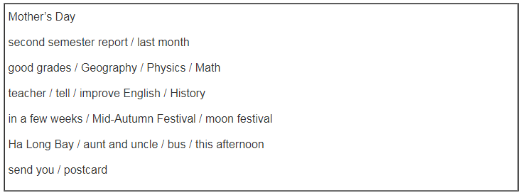

_______________________________________________________________________________________________________________________________________________________________________________________________________________________________________________________________________________________________________________________________________________________________________________________________________________________________

**TIẾT 2: HỌC SINH HỌC VÀ SOẠN BÀI DƯỚI SỰ HƯỚNG DẪN GIÁO VIÊN**

**Unit 5: STUDY HABITS**

(Period 5: Language Focus)

**A. GRAMMAR**

**I/ Adverbs of manner (Trạng từ chỉ thể cách):** Trạng từ chỉ thể cách cho biết điều gì đó xảy ra, hoặc được thực hiện như thế nào. Câu hỏi cho loại trạng từ này là **“How”**

|  |
| --- |
| **Adjective + ly = Adverb** |

**Ex:** careful => careful**ly** happy => happ**ily**

angry => angri**ly** beautiful => beautiful**ly**

**\* Vị trí:**

-Trạng từ chỉ thể cách thường đứng cuối câu (sau túc từ): He ate his breakfast **quickly**.

- Đứng trước động từ thường: The ship **slowly** sailed away.

**\* Chức năng:**

- Trạng từ chỉ thể cách bổ nghĩa cho động từ: She **angrily** tore up the letter.

- Tính từ bổ nghĩa cho chủ từ, danh từ: She is the most **beautiful** girl I have ever met.

**\* Một số trạng từ đặc biệt:**

|  |  |
| --- | --- |
| **ADJECTIVE** | **ADVERB**  **Ex**: Jack loves **fast** cars. He drives very **fast.**  They worked **hard** |
| 1. good | well |
| 2. hard | hard |
| 3. fast | fast |
| 4. early | early |
| 5. late | late |
| 6. deep | deep |
| 7. high | high |

**\* Chú ý:**

1. **Lately** = recently: gần đây

**Ex:** He has come to see me **lately**.

2. **Hardly** = scarcely: rất ít, hiếm khi

**Ex:** I’m not surprised John didn’t find a job. He **hardly** tried to find one

3. **Highly** = very, very much: rất, rất nhiều, vô cùng

**Ex:** We **highly** appreciate any of your contributions

4. **Deeply** = very, very much: rất nhiều, vô cùng

**Ex:** He is **deeply** interested in the project.

**II/ Commands, requests and advice in Reported Speech (câu tường thuật thể sai khiến):**

S + **asked / told**... + O + (not) + **to V**...

**\* Form:**

**\* Note:**

- Biến đổi các đại từ nhân xưng, đại từ sở hữu, tính từ sở hữu cho phù hợp.

- Biến đổi một số trạng từ:

1. now => **then** 4. these => **those**

2. here => **there** 5. today => **that day**

3. this => **that** 6. tonight => **that night**

- Bỏ dấu và “please” (nếu có)

- Các động từ mệnh lệnh: asked (yêu cầu), told (bảo), ordered (ra lệnh), offered (đề nghị), advised (khuyên), warned (cảnh báo), invited (mời), beg (van nài),...

**Ex**: 1. Mai asked her friends: “Don’t wait for me!”

=> Mai **asked** / **told** her friends **not to wait** for **her**.

2. She asked him: “Lend me the books, please.”

=> She **asked** / **told** him **to lend** **her** the books.

3. “Wash your hand before having dinner, Nam.” The mother said

=> The mother **ordered** Nam **to wash his** hand before having dinner.

**\* Advice in Reported Speech (câu tường thuật dạng lời khuyên):**

S + **told** + O + (that) + S + **should** + (not) +**V0**...

**Ex:** “You should stop smoking”, she said.

=> She told me (that) **I should** stop smoking.

**B. PRACTICE**

I/ **Complete the dialogues. Use the adverbs of manner in the box:**

**softly well fast badly hard**

a) Hoa: Does Mrs. Nga speak English?

Lan: Oh, yes. She speaks English (0) **well**.

b) Hoa: Ba always gets excellent grades.

Lan: That's because he studies (1) __________.

c) Hoa: That's our bus!

Lan: Run (2) __________ and we might catch it.

d) Hoa: I'm very sorry. I know O behaved (3) __________.

Lan: It's all right.

e) Hoa: I can't hear you, Lan.

Lan: Sorry, but I'm speaking (4) __________ because I have a sore throat.

**II/ Work with a partner. Look at the picture of Mr. Hao's house. Use the words in the box. Say what he should do.**

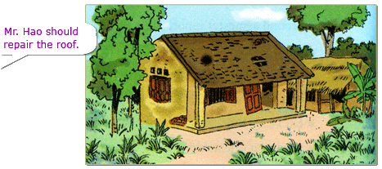

**repair paint cut replant mend**

**Ex:** Mr. Hao should repair the roof.

1. _________________________________________________________.

2. _________________________________________________________.

3. _________________________________________________________.

4. _________________________________________________________.

**III/** **Work with a partner. Suppose you are Tim's mother. Report Miss Jackson's commands and request in her conversation with Tim's mother.**

**Ex:** Miss Jackson said: “Can you give Tim this dictionary?”

or “Please give Tim this dictionary.”

Tim’s mother reported it to Tim:

“Miss Jackson asked me to give you this dictionary.”

“Miss Jackson told me to give you this dictionary.”

1. “Please wait for me outside my office.”

=> _______________________________________________________.

2. “Please give Tim his report card for this semester.”

=> _______________________________________________________.

3. “Can you help Tim with his Spanish pronunciation?”

=> _______________________________________________________.

4. “Can you meet me next week?”

=> _______________________________________________________.

**IV/ Work with a partner. Report Miss Jackson's advice she gave in her conversation with Tim's mother.**

1. “Tim should spend more time on Spanish pronunciation.”

=> _______________________________________________________.

2. “Tim should practice speaking Spanish every day.”

=> _______________________________________________________.

3. “Tim should listen to Spanish conversations on TV.”

=> _______________________________________________________.

4. “Tim should practice reading aloud passages in Spanish”

=> _______________________________________________________.

5. “Tim should use this dictionary to find out how to pronounce Spanish words.”

=> _______________________________________________________.

**V/ Put the following command and requests into reported speech:**

1. Their mother said to them, “Don’t make so much noise.”

=> _______________________________________________________.

2. The traffic policeman said, “Show me your driving license, please”.

=> _______________________________________________________.

3. Mrs. Jackson said to Tim, “Could you give me a hand, please?”

=> _______________________________________________________.

4. The lifeguard said, “Don’t swim out too far, boys.”

=> _______________________________________________________.

5. Nam said to the taxi driver, “Please turn left at the first traffic light.”

=> _______________________________________________________.

**----------------------------🙣✰🙡----------------------------**

**TIẾT 3: SỬA BÀI KIỂM TRA TIẾNG ANH GIỮA HKI**