TUẦN 1 - LỚP 9 | Qui Duc Secondary School

…………… September …..th, 2021

Tiết 1:

UNIT 1: A VISIT FROM A PEN PAL

LESSON 1: GETTING STARTED + LISTEN AND READ

- GETTING STARTED:

II. LISTEN AND READ:

1.

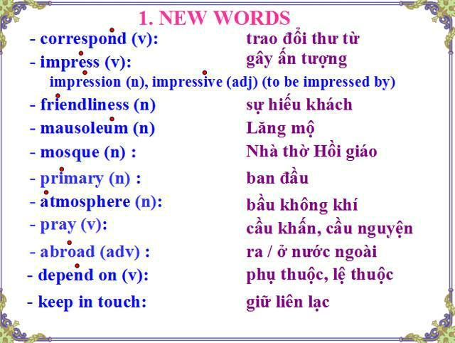

A pen pal (n): bạn qua thư

- “Wish” sentence: ex: I wish I had a longer vacation

Form: S + wish(es) + S + V2/ed (Past simple)

Was/ Were (cho tất cả các ngôi)
Would
Could

TUẦN 1 - LỚP 9 |  |  |  | Qui Duc Secondary School
 | 2. | “ used to + V1”: đã từng
 | 3. | “ be used to + V-ing”: quen với
 | Practice
I. Rewrite sentences, using "I wish........... |  |  |  | "
Cách làm: ngược nghĩa + chuyển quá khứ
1. | She doesn't send me her recent photos.
-> I wish .................................................................................................................
2. | My friend doesn't have money to repair his bicycle.
-> I wish....................................................................................................................
3. | My students don't speak English fluently.
-> I wish....................................................................................................................
4. | It won't be fine tomorrow.
-> I wish......................................................................................................................
5. | My brother can not speak French.
-> I wish.....................................................................................................................

II.Give the correct word formation
1- We like their ___________________ (friendly).

2- The ________________ between Vietnam and China is good. (friend)
3- They seem to be ________________. We dislike them. (friend)
4- There will be a ___________________ in this street. (meet)
5- We saw ___________________ girls there. (beauty)
6- Can you give me some ________________ the next flights to Florida? ( inform )

*ANSWER KEY:

I.

1. I wish she sent me her recent photos

2.I wish my friend had money to repair his bicycle

3.I wish my students spoke English fluently.

- I wish it would be fine tomorrow

- I wish my brother could speak French

II.

1. friendliness 2. friendship 3. unfriendly 4. meeting 5. beautiful 6. information

2

TUẦN
1 - LỚP9

Qui Duc Secondary School

…………… September

th, 2021

Tiết 2

UNIT 1: A VISIT FROM A PENPAL

LESSON 2: READ

- NEW WORDS:

Malaysia is one of the countries of the Association of South East Asian Nations (ASEAN). It is divided into two regions, known as West Malaysia and East Malaysia Malaysian unit of currency (n) đơn vị tiền tệ is the ringgit, consisting of ( bao gồm)100 sen.

The capital of Malaysia is Kuala Lumpur and it is also the largest city in the country. The population in 2001 was over 22 million. Islam (đạo hồi giáo) is the country’s official religion ( tôn giáo chính thức. In addition, there are other religions such as Buddhism (đạo phật) and Hinduism. The national language is Bahasa Malaysia (also known simply as Malay). English, Chinese, and Tamil are also widely spoken. The language of instruction for primary school children is Bahasa Malaysia, Chinese, or Tamil. Bahasa Malaysia is the primary language of instruction in all secondary schools, although some students may continue (tiếp tục) + learning in Chinese or Tamil. And English is a compulsory second language.

Practice:

- Area: 329,758 km2 ( diện tích)

- Population: over 22 million ( dân số)

- Climate: tropical climate ( khí hậu)

- Unit of currency: ringgit

- Capital city: Kuala Lumpur

- Official religion: Islam

- National language: Bahasa Malaysia

- Compulsory second language: English ( ngôn ngữ thứ 2 bắt buộc)

Word form cần thuộc:

  - Office (n) – 0fficial (a) - 0fficially (adv)

  - Religion (n) – religious (a)

  - Compel (v) - compulsory (a)

  - Peace (n) -peaceful (n) – peacefully (adv)

  - Impress (v) – impression (n) – impressive (a) -impressively (adv)

  - friendly (a) – friendliness (n)

3

