### UNIT 8: PLACES

**(LESSON B: B1, B2, B3)**

**Học sinh tự thực hiện B5, tự học B2**

***- Vocabulary***

+ envelope (n) : phong bì

+ stamp (n): tem

+ (to) send a letter : gởi thư

+ (to) mail a letter : gởi thư

+ (to) cost : chi phí

+ change (n): tiền lẻ, tiền thối

**B1. Listen and repeat. Then practice with a partner**

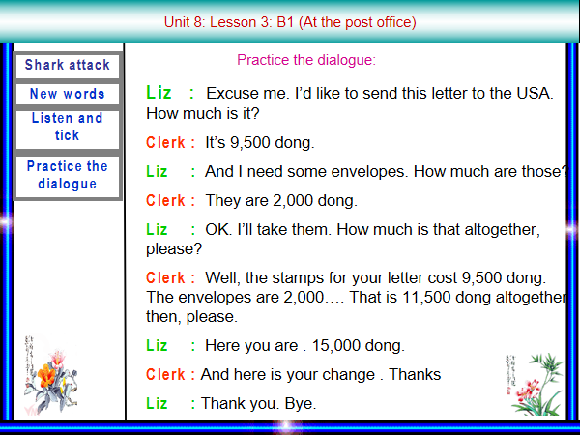

**Answer key**

1. Liz will mail her letter to the USA.
2. She pays 11,500 dong altogether.
3. She receives 3,500 dong in charge**.**

**B2. Listen and read. Then answer the questions**

***Nga and Hoa are going to the post office after school***

**Nga:** What do you want from the post office, Hoa?

Hoa: I’d like some local stamps and some stamps for overseas mail. I have a pen pal in America. His name is Tim.

Nga: how nice! How often do you write to each other?

Hoa: Very regularly- about once a month. He tells me all about his life in America. Oh, I need to buy a phone card at the post office, too.

Nga: Why do you need a phone card?

Hoa: I phone my parents once a week.

Nga: OK. Here is the post office. Let’s go and get the things you need.

**Answer key**

1. Hoa needs some local stamps and some stamps for overseas mail and a phone card.
2. She needs stamps for overseas mail and a penpal in America.
3. She needs a phone card to phone her parents.

**B3. Complete the dialogue. Then make up similar dialogues; use the words in the box.**

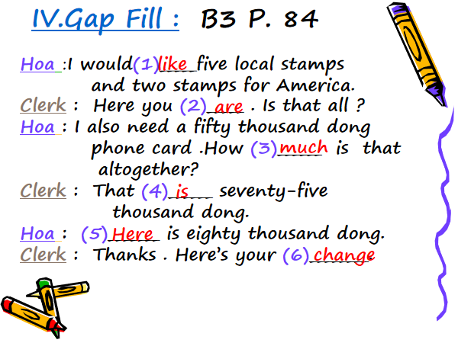

**Dặn dò:**

**- Học từ vựng và ngữ pháp. Đọc lại bài B1,2,3 (Học sinh tự thực hiện B5, tự học B2)**

**- Chuẩn bị ôn tập từ Unit 1-Unit 7.**