EXERCISE - UNIT 3 (THÁNG 11)
Lesson 1
I. Look at the words in the box and write the suitable word for each picture.
jazz pop hip hop classical music rock country music

 | 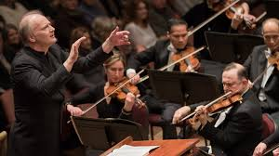 | 
1......... | 2. ............... | 3. ...............
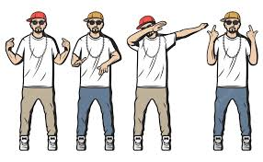 |  | 
4. .................... | 5. .............. | 6. .................
.
II. Circle the correct words.
1. My friend, Jenifer love/ loves country music. She don’t/ doesn’t listen to rock music.
2. My daughter often listen/ listens to her favorite pop songs when she learn/ learns English.
3. I don’t/ doesn’t like listening to jazz. It is/ are boring.
4. Do/ Does your parents like listening to classical music? Yes, they love/ loves it.
5. My brother and I play/ plays the piano every week. We often practice/ practices on the weekend.
6. When do/ does the pop music show start? - It start/ starts at 8.pm.
7. My dad don’t/ doesn’t rock music. He think/ thinks it’s noisy.
8. She enjoy/ enjoys singing country music.
9. Is/ Does Jenny like listening to pop music? Yes, she is/ does.
10. What kind of music do/ does she like listening to? She like/ likes listening to jazz.

