EXERCISE 2 (THÁNG 01)
Lesson 2
I. Look at the words in the box and write the suitable word for each picture.
boring interesting fun terrible exciting beautiful

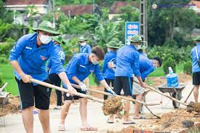 |  | 
1. __________ | 2. __________ | 3. __________
 |  | 
4. __________ | 5. __________ | 6. __________

7. __________

II. Give the correct form of the verbs in brackets.
1. Last Saturday, Anna and his friends (volunteer)__________ at the soup kitchen.
2. We (clean up)__________ the park near our school last weekend.
3. My parents (raise)__________ money to help the local children's hospital two years ago.
4. Last week, lots of students (donate)__________ books and clothes they (not use)__________ any more to poor children in their town.
5. Our school (collect)__________ all of the donations and sent them to poor people.
6. They (plant)__________ frees in the streets to make their town cleaner.
7. Jenny (take)__________ a lot of photos last week.
8. My brother (wash)__________ his car yesterday morning.
9. We (help)__________ some poor children in our neighborhood study English last year.
10. We (plan)__________ to recycle all those papers two weeks ago

