EXERCISE (THÁNG 01)
Lesson 1
I. Look at the words in the box and write the suitable word for each picture.
car wash bake sale craft fair talent show
fun run

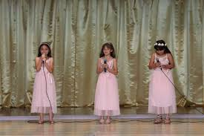 | 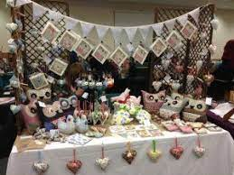 | 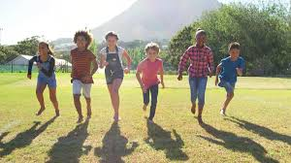
1. __________ | 2. __________ | 3. __________
 | 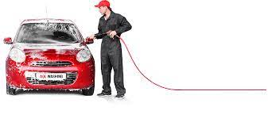
4. __________ | 5. __________
.
II. Choose the correct word.
1. Let’s organize/ organizing a charity event to support for poor students in our village.
2. We should help/ helping all poor children go to school.
3. How about raise/ raising more money for poor people before Tet Holiday?
4. Let’s not use/ using this car more because it is too old.
5. We should donate/ donating old books and clothes for children who are living in remote area.
6. How about we use/ using the money from these events to buy clothes, books, food for poor people?
7. I’m not good at English. Let’s ask/ asking my sister to help these exercises.
8. I think we should sell/ selling these paintings to get some money.
9. How about help/ helping our local community on the weekend?
10. We should plant/ planting some trees in our school yard as soon as possible.

