UNIT 5. FOOD AND DRINKS. EXERCISE (A)
III. Circle the correct word.
1. How much/ many apples do we need?
2. Do you have much/ many bananas left?
3. How much/ many tomatoes do you have?
4. How much/ many eggs this hen produced in this week?
5. How much/ many flour is there in this bag?
6. How much/ many onions do you need?
7. Don’t use too much/ many sugar every day.
8. How much/ many lemons does your mother want?
9. How much/ many butter do you need for making this cake?
10. Don’t use too much/ many spaghetti. We have some other food left.
II. Look at the words in the box and write the suitable word for each picture

bag bunch can bar bottle stick carton (x2) box

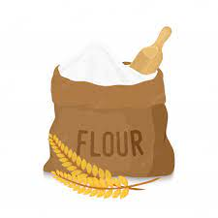 | 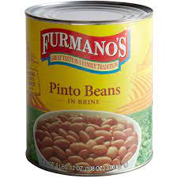 | 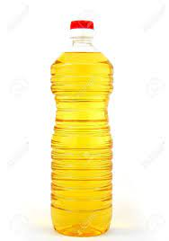
1. a______ of flour | 2. a______ of beans | 3. a______ of oil
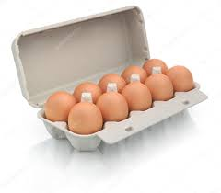 | 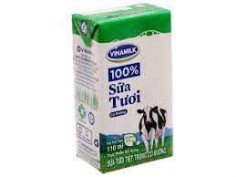 | 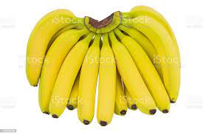
4. a______ of eggs | 5. a______ of milk | 6. a______ of bananas
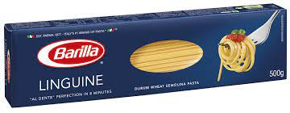 | 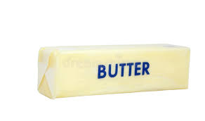 | 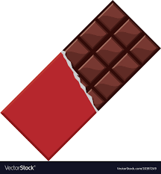
7. a______ of spaghetti | 8. a______ of butter | 9. a______ of chocolate

III. Fill in the blanks using the correct article “a/ an/ the”. (Vocabulary)
1. My mother bought me__________ interesting book about Geography.
2. There is__________ can of peas in the cupboard.
3. My little son likes eating__________ ice cream right now. __________ ice cream tastes strawberry.
4. There is__________ big bottle of milk in the fridge.
5. She bought some coffee for me.__________ coffee tasted chocolate.
6. There is__________ bag of rice under the table.
7. My father bought__________ carton of eggs. He put__________ carton in the fridge.
8. There is__________ bunch of bananas. My mom put__________ bunch of bananas on the table.
9. My daughter bought__________ can of beans. I put __________ can of beans in the cupboard.
10. I need__________ box of chocolate. __________ box of chocolate is black.
THE END

